| The Coversheet | |
| --- | --- |
| Student Name  (unless anonymised) | Mohamed Arshad Mohamed Haris |
| Student Number  (as shown on student ID card): | 240184339 |
| Word Count / Pages / Duration / Other Limits: | 13814 |
| Attempt Number: | 1 |
| Date of Submission: | 21/01/2025 |

|  |  |
| --- | --- |
| I have read and understood the [Academic Misconduct statement](https://blog.yorksj.ac.uk/assessment/coversheet-statements/). | Tick to confirm |
| I have read and understood the [Generative Artificial Intelligence use statement](https://blog.yorksj.ac.uk/assessment/coversheet-statements/). | Tick to confirm |
| I am satisfied that I have met the Learning Outcomes of this assignment  (please check the Assignment Brief if you are unsure) | **​​​** Met |

|  |
| --- |
| **Self-Assessment** – If there are particular aspects of your assignment on which you would like feedback, please indicate below.  Optional for students |
| ***Suggested prompt questions-***  *How have you developed or progressed your learning in this work?*  *What do you feel is the strongest part of this submission?*  *What feedback would you give yourself?*  *What part(s) of this assignment are you still unsure about?* |
|  |

**DATABASE MANAGEMENT SYSTEM (DBMS) FOR A RESTAURANT CHAIN**

Table of Contents

1 The Coversheet 1

2 Introduction 7

2.1 Lagacy of the Restaurant chain 7

2.2 Significance of the Database Management System (DBMS) 7

2.3 Intent of the Assessment 8

3 Requirement Analysis 8

3.1 Functional Requirements 9

3.2 Non-functional Requirements 9

3.3 System Constraints 10

4 Database Design 11

4.1 Data model overview 11

4.2 Entity-Relationship Diagram 12

4.2.1 Description of Entities 13

4.3 Detailed description of entities, attributes and relationship 14

4.4 Business Rules and Assumptions 19

4.4.1 Assumptions 20

4.4.2 Business Rules 20

4.4.3 General rules and assumptions that relate specifically to an entity 21

5 Normalization 23

5.1 Preliminary ERD examination 23

5.2 Normalization process for each entity (1NF, 2NF, 3NF) 24

6 Database Creation and Implementation 28

6.1 Create Database 29

6.2 Create Tables 30

6.2.1 Customer table creation 30

6.2.2 Category table creation 31

6.2.3 Menu_item table creation 31

6.2.4 Restaurant_location table creation 32

6.2.5 Reservation table creation 32

6.2.6 Sales table creation 33

6.2.7 Ingredient Category table creation 33

6.2.8 Inventory table creation 34

6.2.9 Menu Ingredient table creation 34

6.2.10 Employee table creation 35

6.2.11 Shift table creation 35

6.2.12 Supplier table creation 36

6.2.13 Supply Order table creation 37

6.2.14 Payment table creation 37

6.2.15 Feedback table creation 38

6.2.16 Promotion table creation 38

6.2.17 Menu Item and Promotion junction table 38

6.3 Value Insertion 39

6.3.1 Customer data insert 39

6.3.2 Category data insert 40

6.3.3 Menu_Item data insert 40

6.3.4 Restaurant location data insert 40

6.3.5 Reservation data insert 41

6.3.6 Sales data insert 41

6.3.7 Ingredient Category data insert 42

6.3.8 Inventory data insert 42

6.3.9 Menu Ingredient data insert 43

6.3.10 Employee data insert 43

6.3.11 Shift data insert 44

6.3.12 Supplier data insert 44

6.3.13 Supply Order data insert 45

6.3.14 Payment data insert 45

6.3.15 Feedback data insert 46

6.3.16 Promotion data insert 46

6.3.17 Promotion_menu_item data insert 47

7 Query Development 47

8 Report and Analysis 55

8.1 Daily Revenue report 55

8.2 Itemized Sales by Category 57

8.3 Inventory report 60

9 System Deployment 61

10 Security Consideration 63

11 Limitation and future enhancement 65

11.1 Recognized restriction 65

11.2 Improvements 67

12 Conclusion 69

13 References 70

14 Appendices 70

List of Figures

Figure 1: Entity Relationship Diagram 13

Figure 2: naming the database 29

Figure 3: appearing of restaurant chain db database 30

Figure 4: creation of customer table 31

Figure 5: creation of category table 31

Figure 6: creation of menu item table 32

Figure 7: creation of restaurant location table 32

Figure 8: creation of reservation table 33

Figure 9: creation of sales table 33

Figure 10: creation of ingredient category table 34

Figure 11: creation of inventory table 34

Figure 12: creation of menu ingredient table 35

Figure 13: creation of employee table 35

Figure 14: creation of shift table 36

Figure 15: creation of supplier table 36

Figure 16: creation of supply order table 37

Figure 17: creation of payment table 37

Figure 18: creation of feedback table 38

Figure 19: creation of promotion table 38

Figure 20: creation of promotion menu item table 39

Figure 21: inserting customer data values 39

Figure 22: inserting category data values 40

Figure 23: inserting menu item data values 40

Figure 24: inserting restaurant location data values 41

Figure 25: inserting reservation data values 41

Figure 26: inserting sales data values 42

Figure 27: inserting ingredient category data values 42

Figure 28: inserting inventory data values 43

Figure 29: inserting menu ingredient data values 43

Figure 30: inserting employee data values 44

Figure 31: inserting shift data values 44

Figure 32: inserting suppler data values 45

Figure 33: inserting supply order data values 45

Figure 34: inserting payment data values 46

Figure 35: inserting feedback data values 46

Figure 36: inserting promotion data values 47

Figure 37: inserting promotion menu item data values 47

Figure 38: Total sales for each menu category 48

Figure 39: results of Total sales for each menu category 49

Figure 40: Top 10 most popular menu items 50

Figure 41: results of Top 10 most popular menu items 51

Figure 42: Customer reservation history 51

Figure 43: results of Customer reservation history 52

Figure 44: Current inventory levels by ingredient 53

Figure 45: results of Current inventory levels by ingredient 54

Figure 46: Revenue by restaurant location 54

Figure 47: results of Revenue by restaurant location 55

Figure 48: finding daily revenue query 56

Figure 49: outcome of daily revenue 56

Figure 50: bar char for daily revenue 56

Figure 51: query for itemized sales by category 57

Figure 52: results of the itemized sales by category 58

Figure 53: pie chart for the itemized sales by category 59

Figure 54: query for inventory report 60

Figure 55: output of the itemized sales 60

Figure 56: line graph for inventory report 61

Figure 57: AWS management console for deployment 63

Figure 58: final scatch of ER diagram 71

Figure 59: first try of ER diagram scatch 72

Table of Tables

Table 1: final result of supplier table after normalization 24

Table 2: final result of supply order table after normalization 24

Table 3: final result of inventory table after normalization 24

Table 4: final result of ingredient category table after normalization 25

Table 5: final result of employee table after normalization 25

Table 6: final result of shift table after normalization 25

Table 7: final result of payment table after normalization 25

Table 8: final result of sales table after normalization 26

Table 9: final result of customer table after normalization 26

Table 10: final result of feedback table after normalization 26

Table 11: final result of reservation table after normalization 26

Table 12: final result of restaurant location table after normalization 27

Table 13: final result of promotion table after normalization 27

Table 14: final result of menu item table after normalization 27

Table 15: final result of category table after normalization 27

Table 16: final result of menu ingredient table after normalization 28

# Introduction

## Lagacy of the Restaurant chain

Originally the restaurant operation started with one outlet whose core competence was on providing quality meal services and now it has transformed into a rapidly growing organization with multiple outlets. It has grown over the periods, with exceptional standards in food services, and boasts a variety of food and drinks such as appetizers, main entrees, deserts and beverages. This has been driven by a passion for delivering innovative and excellent services hence becoming a leading go to brand in the food industry. As of the current time it holds many stores in the right areas that can serve a broad market, customers ranging from families, business people and even individuals dining. Its menu offers basically all types of food available for human consumption; thus the specialty and favourite of many coming with dishes prepared to suit the various groups’ palates. Is very busy serving hundreds of customers per day and that is why in every meal prepared they pay much attention in providing quality meals.

This has been evidenced by the following operational factors as the business grows: Co-ordinating book-keeping of the reservations, monitoring the stock in more than one location, handling daily sale and achieving high customer satisfaction have worked out more challenging. To solve these problems the chain is going to introduce a contemporary Database Management System (DBMS). This system will offer real-time data and information as well as efficient procedures to make the business competitive and prepared better for growth in the future.

## Significance of the Database Management System (DBMS)

Specifically, the goal of the DBMS is to create an integrated solution allowing a restaurant chain to optimize its work at once in many locations. With the help of sophisticated and modern database system, the system is developed in such a way that it will eventually improve the operational functions, supplement the enhancements of accuracy of data, and enable data-derived decision-making. The first goal is to increase the level of reservation optimization so that customers can place and cancel the reservation themselves, as well as solve the problem of overbooking. Also, based on DBMS, inventory management is also targeted to be enhanced, offering real-time info and possible alerts about any inventory levels lower than a set point. This centralisation will also help in sales processing where the administrative office will collect daily sales data and prepare details reports for management analysis.

Additionally, the implementation of a DBMS will help to improve the experience of customers by providing protection of the customer’s details, including their names, contact details, and records of their reservations with a view to directing marketing and arriving at an intimate understanding of such customers. It will also guarantee menu oversight, that is, storing important details relating to menuing locations and descriptors. Reporting and analytical tools will help managers to reflect on such indicators as sales by menu category, food inventory consumption, revenue by the territorial divisions. In the long run, the DBMS will enhance efficiency in the restaurant chain, augment customer relations, as well as enhance the formation of good decisions for the business’s further development.

## Intent of the Assessment

The main goal of this herein assessment is to develop and practice a DBMS solution for a restaurant business. It encompasses formulating a conceptual architecture that embodies these important business concepts as customers, reservations, menu, stocks, and sales. The system will ensure proper relationships between these entities Then, by applying techniques such as normalization techniques up to Third Normal Forms (3NF), data redundancy will be avoided. Therefore, through the development of the Entity-Relationship Diagram and checking the design against business rules means that the aim is developing a sustainable long-term database from an operational perspective. Further to this, to evaluate the functionality of the created database, sample data will be added at a later date to the database.

The DBMS will also entail creating essential SQL queries to meet the company’s business needs such as; capturing orders, most often ordered meals, reservation history of the customers, and stock availability. Adoptions of security features will be made with regards to Recovery of sensitive data and; Privacy and Data protection compliance will be made to the standard industry regulations. In addition, specific reports together with adequate documentation will be rendered to meet the business operation requirement. The last goal is advisory about further advancements so that the DBMS is capable of sustaining growth and development according to novel business requirements that would help improve overall productivity and organization standards for customers.

# Requirement Analysis

In the case of requirements gathering and analysis, it allows for final design of the database to reflect the requirements of the stakeholders as well as the users. It lowers the probability of misunderstanding and achieved the most viable design at the initial phases and before a lot of cost is invested on the product (Anon., n.d.). As will be further demonstrated in this paper, requirements analysis plays a central role in the understanding of operations of the restaurant chain and aligning the DBMS to its needs. It reduces the probability that a system will be built without achieving the intended requirements by identifying various functional and non-functional requirements at inception. This process is also useful for the design of the database where key decision about the models, relations between them and architecture of the databases under consideration and possible risks will be managed including issues such as scalability and offences made against compliance standards. Moreover, it simplifies the process of time and budget planning and utilization, highlighting those features that will be most valuable.

Carried out at the beginning of a project, requirements analysis outlines the goals, and results of a project. That is useful in the development of Entity-Relationship Diagram (ERD), normalization, schema establishment and it allows for efficient performance, expansibility and legal requirements. These include services in reservation management, for instance, and the sales in reporting functions to facilitate communication gaps among stakeholders and developers. Thus, it helps to check the DBMS’s suitability for being employed in the everyday functioning of the restaurant chain by reference to the DBMS during testing and to account for numerous changes, it is helpful in terms of the restaurant chain’s strategic vision.

## Functional Requirements

The DBMS should meet the following specific functional requirements to help the restaurant chain.

* Manage Customer Reservations,
* Book, modify, and cancel.
* Show per location availability in the form of an online table.
* Track Customer Information,
* Retailers should maintain customers details, their choices and whether they belong to any special club or not.
* Keep and update a reservation history for each customer.
* Monitor and Manage Inventory,
* Register the places where stocks of ingredients and supplies are found.
* They should produce notification when the stock is getting low and automatically generate purchase orders.
* Keep Record on the Menu and the Sales.
* Organize food items in different categories, their prices and serving status.
* Monitor sales and determine revenue for a product category, product type and store.
* Generate Reports
* Prepare daily report on sales, stock and reserved tables etc.
* Give reports based on the number of units sold, market revenue, and customers’ preference.
* Security and Data Compliance
* Always encrypt your data if you want to secure it or if data access must be restricted.
* Our website follows some standard regulation like GDPR and PCI DSS.

## Non-functional Requirements

The following non-functional criteria has to be fulfilled by the DBMS in order to work efficiently and effectively

* Scalability for Future Growth:
* The system should also scale up to incorporate other factors such as new restaurants’ outlet, new foods to be offered on its menu, and customers.
* It has to support greater volumes of data and user traffic as the firm grows.
* Secure Data Handling:
* Ensure safe, secure and proper protection of user private data, including the phone numbers and other details related to payments.
* Use something known as role-based access control to prevent outside interference on important data.
* Conformity to the rules of the industry at the international level and at the European level in particular, and the mandatory compliance with GDPR and PCI DSS requirements.
* High System Availability:
* Assure a minimum of 99.9% server up time for meetings customers’ business needs 24/7 including reservation changes and real time inventory.
* Build redundancy systems for the particular equipment or computer systems to allow business operation during system failure.
* Performance and Efficiency:
* The software system should be able to accommodate up to one thousand users during the hours of high traffic and not lag.
* To satisfy the user experience, which involves executing standard queries, the system should perform them within 2 seconds.
* Maintainability and Usability:
* Envision a decently structured LMS with Open Education Elements in a way that easy modifications and improvements can be made.
* Provide a simple design such that most of the workforce will not need training to operate it.
* Data Integrity:
* Use constraints, trigger and validations to enable the management of appropriate data integrity and consistency.

## System Constraints

The DBMS has to work under the following constraints and limitations

* Budgetary Limitations

The usage of high-cost technologies, the purchase of premium third-party tools, as well as extensive custom solutions cannot be effectively afforded because the development and deployment need to fit into a set price point.

* Existing dependencies with both hardware and software.

The DBMS must be compatible with the restaurant’s current hardware platforms servers’ workstations and networks. In addition, it should easily run on it with other currently running software systems including POS systems, accounting systems, and customer management systems.

* Compliance Requirements

Such regulations include data protection laws; general data protection regulation, health insurance portability and accountability act (HIPAA) or payment card industry data security standard (PCI- DSS) in handling of sensitive information.

* Data Volume and Performance

Large amount of data such as past sales, customer information, and stocks should be stored in the DBMS without impacting on its performance.

* Deployment Timeline

The implementation of the forecasting system must not violate the laid down time line of the project in order to cause operational hitches.

* Scalability and Flexibility

However useful, establishing this type of system must not expand beyond the framework of the current architecture at the early stages of implementation.

# Database Design

Data science, research, business, or just about anything else necessitates databases as the primary method of capturing and disseminating the information that is it is important to protect and house. Proper data, especially statistically intensive work, must adhere to reliable data integrity, and the appropriate approach to its database design guarantees data scalability, as well as top run-time performance, which is a deliberate organizational imperative for environments employing data intensely, which would more than include statistical analysis (Mayo, 2025). When setting up a database there is need to design the structure of the database so as to provide a structure that can handle the operational needs of the restaurant chain. This make sure that data is accurate, prevents duplication and enable easy integration of crucial tasks such as reservations, inventory, and sales management. Well-planned database optimizes the capability of fuzzing the queries, fortified data security and compliance with rules and regulations. It provides the base of business alignment that outlines the analytics for customer behaviours, sales and inventory information, hence, boosting operation efficiency and decision-making processes in businesses.

## Data model overview

According to the goal of this assignment, the database design should support an effective plan and create a strong foundation for the restaurant chain. It connects essential objects such as customers, reservation, menu, stock, and sales; hence, the systems facilitate the flow between business operations. Key entities capture essential details: The customer information helps to provide an individual service, reservations allow for the availability of tables in the instant moment, menu items enable the regulation of food and beverage, inventory provides information on stock and suppliers and sales assist in making transactions for the analysis. Ensuring that the design is case of Third Normal Form (3NF) there is minimization of redundancy, consistency and hence query optimization. For example, instead of duplicate information, customer information is being stored once only and referenced using foreign keys. This model can be easily extended for additional locations and provides tools for generation of reports and analysis containing information on sales performance, customer preferences, and stock control to enhance operation effectiveness and revenue increases.

## Entity-Relationship Diagram

An entity relationship diagram (ER diagram or ERD) can be looked at as a simple chart that shows how the different items in a database are connected. ERD is a specific form of a flowchart that shows the kinds of connections between the entities of a system. It is composed of only certain symbols, such as rectangles, ovals, and diamonds and join the shapes solely with lines (Belcic & Stryker, 2024). It is important when constructing a database since it provides visual representation of data relationships in a system known as Entity-Relationship Diagram (ERD). They assist in identifying entities, attributes and relationships when designing a database, when a system is complex a conceptual data model makes it easier to design a database. ERDs help in the elimination of confusion between the development team and other stakeholders besides the database, and during the implementation process. ERDs classify data in a rationalized manner to help in scaling, maintaining and querying the database solution to match business needs suitably.

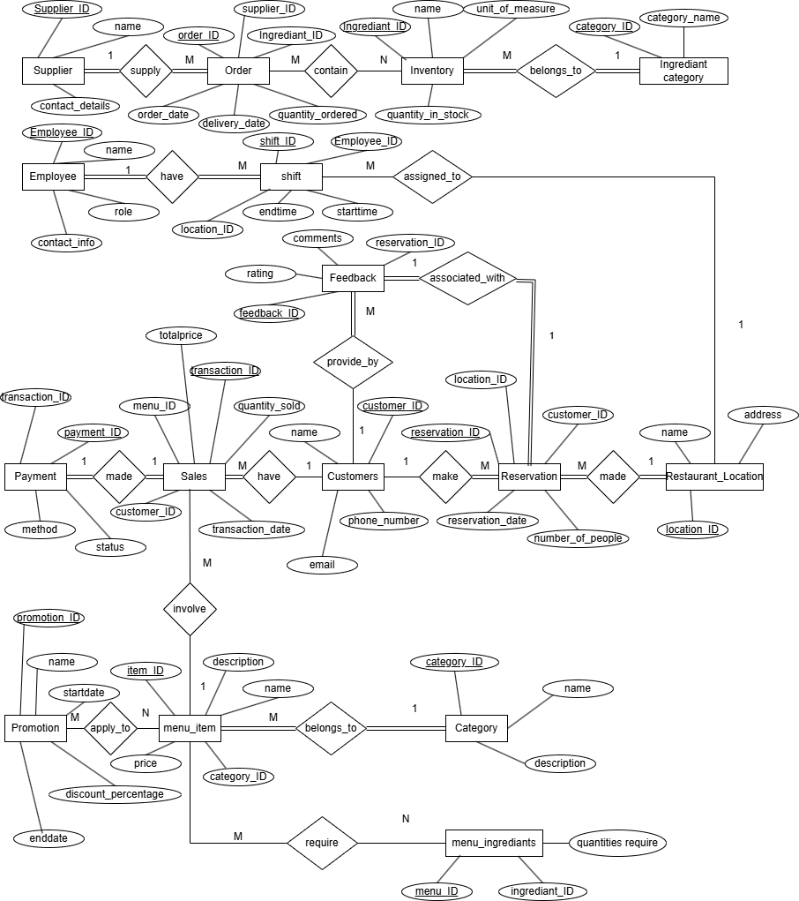

Figure 1: Entity Relationship Diagram

### Description of Entities

* Menu_Item: Holds information about the meals, the unique ID of the item, name, description, price and the category ID, which connects the meals with the categories.
* Category: Has info
* rmations about the category such as category id, name and description for group menus like appetizers or drinks.
* Customer: Saves customer data like customer code, customer name, customer email, and customer phone for easy services and communications.
* Reservation: Records every customer’s reservation with features such as reservation number, customer number, location number, reservation date, and the number of guests.
* Restaurant_Location: Used as restaurant database with the fields as location identifier, name of the restaurant and address especially for multiple stores.
* Sales: Maintains the sales record in a way that includes the transaction ID, customer ID, menu item ID, transaction date, quantity sold, transaction price.
* Inventory: Stores information about food or any recipe that includes the ingredient ID, name of the ingredient, the quantity in stock and the unit of measure used.
* Ingredient_Category: A category is a means by which ingredients are sorted by a particular category ID and name that may include spices and dairy products.
* Menu_Ingredient: Establishes association between menu items and their preparation ingredients by writing down the menu item’s identification number, the ingredient identification number, and quantity used in preparing that meal.
* Employee: Tags employee identification number, name, organizational position, and means of contacting the human resource to ensure staffing integrity.
* Shift: Helps track work schedules of employees by shift ID, employee ID, location ID, shift start and end time.
* Supplier: Holds information about the specific supplier like supplier number, name and other information about the ingredients to be supplied.
* Supply_Order: Its fields are to track Orders regarding Order ID, Supplier ID, Ingredient ID, Quantity Ordered, Order Date and Delivery Date.
* Payment: Maintains records of payment solutions like payment ID, transaction ID, mode of payment and status of the payment.
* Feedback: Collects customer feedback with feedback ID, customer ID, reservation ID, rating, comments to track the improvement in the quality of the customer service.
* Promotion: Promotional offers to be tracked include promotion ID, name, discount percentage, date the promotion started and date it ended with a view of getting customers.

## Detailed description of entities, attributes and relationship

* Supplier
* Attributes:

supplier_id: Key that distinguishes one supplier from another.(unique identifier)

name: Supplier’s name, who supply order.

contact_details: Data with regard to the supplier like phone number.

* Relationships:

Supplier ↔ Supply_Order:

Type: Supplier may place one or many Supply_Order; A many-to-one relationship also exists where Supply_Order may originate from one or many Supplier.

* Order
* Attributes:

order_id: Identification parameter for the supply order.

supplier_id: There shall be foreign key linking the order with the supplier.

ingredient_id: Foreign key linking it to the specific ingredient it has ordered.

quantity_ordered: Amount of the ingredient that was needed to prepare the recipe that was ordered.

order_date: Date the order was placed.

delivery_date: Expected delivery date.

* Relationships:

Supply_Order ↔ Supplier:

Type: Supplier to many One-to-Many (Supplier → Supply_Order).

Supply_Order ↔ Inventory:

Type: Inventory withdrawal (1 : *), Supply Order (1 : *)

* Inventory
* Attributes:

ingredient_id: A stock number, or other item number associated with the ingredient, that can be used to locate the ingredient.

name: Name of the ingredient.

quantity_in_stock: Current stock quantity.

unit_of_measure: The amount of the food ingredient measured in relevant standards or units including but not limited to kilograms, liters, grams, milliliters.

category_id: Forgen key linking the ingredient to its category.

* Relationships:

Inventory ↔ Ingredient_Category:

Type: Many-to-One (Ingredient_Category |→| Inventory).

Inventory ↔ Menu_Ingredient:

Type: Many-Many (Menu_Item – Inventory through Menu_Ingredient).

Inventory ↔ Supply_Order:

Type: A second type is a one-to-many relationship (Inventory → Supply_Order).

* Ingredient_Category
* Attributes:

category_id: Every ingredient has this or he has another, and this is the unique number for the ingredient category.

category_name: The names given to the various groups of the ingredients.

* Relationships:

Ingredient_Category ↔ Inventory:

Type: One to Many in which, Ingredient_Category and Inventory join together in the role of Inventory.

* Employee
* Attributes:

employee_id: General identifier for the employee which is unique.

name: Employee’s full name.

role: The nature of the service delivered by the employee in the company, that is, corporate, contractual or other.

contact_info: Details of the employee in terms of contact information.

* Relationships:

Employee ↔ Shift:

Type: 1:M (Employee → Shift) shortage situation.

* Shift
* Attributes:

shift_id: A distinctive designation of the shift.

employee_id: Foreign key linking the shift to the employee. it has developed and maintained a connection between foreign key and the shift to the employee that can support its operations through effective and efficiency performance.

location_id: Foreign key linking the shift with the restaurant location.

start_time: Start time of the shift.

end_time: End time of the shift.

* Relationships:

Shift ↔ Employee:

Type: One-to-Many (Employee → Shift) Relationships Explain How Organizational Communication Can Help Managers in Achieving Organizational Goals.

Shift ↔ Restaurant_Location:

Type: One-to-Many (Restaurant_Location → Shift).

* Payment
* Attributes:

payment_id: This is a reference number assigned to payment.

transaction_id: A foreign key connects the payment made to the sales transaction.

method: Mode of payment, for example cash, card.

status: Type of payment that has been made or type of payment that is yet to be made.

* Relationships:

Payment ↔ Sales:

Type: One-to-One (Payment ↔ Sales).

* Sales
* Attributes:

transaction_id: Each sale that occurred on the platform has this identifier which is used to distinguish it from all other sales.

customer_id: A foreign key linking the transaction with the lead customer specifying the type of transaction.

menu_item_id: Foreign key linking the transaction with the respective menu item.

transaction_date: Time and date of the transactions.

quantity_sold: How many pieces of the specific food item have been sold.

total_price: Applied to the whole given transaction and is the overall price of the object.

* Relationships:

Sales ↔ Customer:

Type: Sale(person → Customer).

Sales ↔ Menu_Item:

Type: One to Many (Menu_Item → Sales).

Sales ↔ Payment:

Type: One-to-One (Payment ↔ Sales).

* Customer
* Attributes:

customer_id: Distinctive number given to the client.

name: Customer’s full name.

email: The email address of the customer.

phone_number: Phone number of the customer.

* Relationships:

Customer ↔ Reservation:

Type: Customer – Reservation (Selling One Product to Many Customers).

Each reservation can be made by one customer, but a customer can make several reservations.

Customer ↔ Sales:

Type: Customer to Sales (One-to-Many).

A sale can be made to one or several customers but a customer can only be related to one or several sale(s).

Customer ↔ Feedback:

Type: The last type is one to many which is a customer giving feedback to a company for instance.

A customer can submit several entries of feedback, yet each feedback entry is firmly associated with a unique customer.

* Feedback
* Attributes:

feedback_id: The reference number of the feedback.

customer_id: Foreign key linking the feedback with the customer.

reservation_id: Foreign key linking the feedback to the reservation system.

rating: Customer’s rating.

comments: Customer’s comments.

* Relationships:

Feedback ↔ Customer:

Type: Customer → One-to-Many (Feedback).

Feedback ↔ Reservation:

Type: One-to-One (Feedback ↔ Reservation).

* Reservation
* Attributes:

reservation_id: It is the foreign key to make this table for the reservation with a unique identifier.

customer_id: This key links the reservation to the customer thereby assisting in differentiating the two.

location_id: Foreign key linking the reservation to the restaurant location is also required.

reservation_date: Details of a reservation including time and date of the reservation.

number_of_people: Number of people considered in the reservation.

* Relationships:

Reservation ↔ Customer:

Type: Customer – Reservation, One to Many:

Reservation ↔ Restaurant_Location:

Type: One to Many (Restaurant_Location to Reservation)

Reservation ↔ Feedback:

Type: One to One (Feedback To Reservation).

* Restaurant_Location
* Attributes:

location_id: A random identification number for the restaurant location.

name: Type of the restaurant location.

address: Address of the location.

* Relationships:

Restaurant_Location ↔ Reservation:

Type: One to Many (Restaurant Location –> Reservations).

Restaurant_Location ↔ Shift:

Type: Many-to-One (Restaurant_Location ← Shift).

* Promotion
* Attributes:

promotion_id: The promotion has its own number of identification.

name: Name of the promotion.

discount_percentage: Discount percentage offered.

start_date: Start date of the promotion.

end_date: End date of the promotion.

* Relationships:

Promotion ↔ Menu_Item:

Type: Many-to-Many (Promotion and Menu_Item are joined by a many-to-many relationship using a junction table).

* Menu_Item
* Attributes:

item_id: It is the identification number assigned to the particular menu item.

name: Name of the menu item.

description: Description of the menu item.

price: Price of the menu item.

category_id: Foreign key to linking the menu item with the particular category that this item falls under.

* Relationships:

Menu_Item ↔ Category:

Type: Other type of ML association is One-to-Many (Category → Menu_Item).

A menu item is a member of a category but a category may contain several menu items.

* Category
* Attributes:

category_id: It is a database unique ID for the category entry.

name: Name of the category.

description: Description of the category.

* Relationships:

Category ↔ Menu_Item:

Type: Many-to-One (Menu_Item → Category).

* Menu_Ingredient
* Attributes:

menu_item_id: An example of this would be foreign key linking to the menu item.

ingredient_id: Foreign key relating to the ingredient.

quantity_required: Amount of that ingredient needed to prepare and serve the menu offering.

* Relationships:

Menu_Ingredient ↔ Menu_Item & Inventory:

Type: Many-to-Many (Menu_Item ↔ Inventory through Menu_Ingredient).

## Business Rules and Assumptions

Assumptions and business rules is a very important factor in the assessment and implementation of a system since they offer direction, make decisions, and set expectations for the system. Assumptions mitigate risks, help map out plans, and also ensure that any system designed can be scaled up when needs arise. To avail the benefits of consistency, efficiency, conformity to business standards and flexibility as well as to improve the customer experience, business rules are used. Combined, they establish uniformity, eliminate the need for human interventions in decision making and foster the development of sound and sustainable models that support organizational objectives. By increasing clarity, they enhance the decision-making process and enhance the probability of delivering the project.

### Assumptions

* Customer and Reservations
* One customer can make several reservations to support return clients since multiple reservations refer to many persons.
* Every reservation can be associated with one and only one customer in order to enhance service differentiation and identification.
* Pre-orders are obligatory, and all customers have to give their valid phone numbers.
* Menu Items and Inventory
* Goods purchased from other outlets are ordered by the management having in mind its seasonality as well as the availability of stocks.
* Recipes cannot be cooked or dish be served, if its constituents are not available in the kitchen.
* For every item in the Menu, a Menu_Ingredient table has provided the link to track the ingredients correctly.
* Inventory Management
* Every manufactured inventory item has a particular numerical ingredient_id through which stock control is intricately implemented.
* Consumers have ability to sell or restock products in real time in an organization’s stock.
* There is the Ingredient_Category which helped substantially in the classification of ingredients for a better analysis of ingredient data.
* Sales and Customer Records
* Due to the convenient and additional tracking and to give superior customer service, possible sales related to products on the menu and customer records are connected.
* Sales volume and total sale figures are the other data gathered from which financial quantification can be generated almost instantaneously.

### Business Rules

* Reservation Policy and Locale Capabilities
* System has limited number of reservations possible on the basis of seating capacity of every outlet of restaurants so that comfort of customers and feasibility of operations is not compromised.
* The system displays the number of people to be served at a particular instant and the number of chairs in a restaurant and compares them before booking.
* System and Management of Inventory Alerts
* The inventory level of each item is real-time and automatically issues a warning when it reaches below a particular level known as reorder level.
* Reorder point template is used for creating automatic or manual supply orders to restock out of stock raw materials for continuous functioning.
* Supply_Order is the entity connecting suppliers with ingredients to facilitate buying and delivery of the materials.
* Discounts and Promotions
* Promotional prices on products are captured at the time of a sale which makes billing to be clear and accurate.
* The Promotion entity enables many products on the menu to be linked to a particular promotion, and many promotions to be linked to particular meals through the use of a many-to-many table.
* This is on the basis of time restrictions, where each promotion has a start and an end date by which it should have been implemented.
* Data Compliance and Security
* Customer’s privacy is also kept safe through encryption of data such as email addresses and customers’ payment details.
* Great and the payment data has to meet certain requirements such as the Payment Card Industry Data Security Standard (PCI DSS) to minimize payments fraud.
* If it comes to their Customer and Financial information, customers and financial data could only be accessed by authorized personnel.

### General rules and assumptions that relate specifically to an entity

Customer

* Every client has a customer_id that separates the person from every other client. This is so because customers need to provide their contact details so as to facilitate the communication of issues regarding their reservations, and feedback.

Reservation

* It focuses on the reservation_date and the number_of_people as far as the management of seating allocation is concerned. Each reservation has a location identification number which links the record to a location.

Menu_Item

* Items are selected by customers through the Category entity to ease the display of menus and generating of reports. Quantity pricing is changed from time to time considering cost and quantity demanded.

Inventory

* Connected to the Ingredient_Category entity, each ingredient is connected to its’ category, improving the quality of reporting and procurement. Availability information of stock is always up to date due to the real time information feeds.

Sales

* A sales transaction is characterized by a transaction_id that is also used to identify each record of sales transaction and other attributes such as quantity_sold and total_price. Sales can be associated with customers and menu items as per the customers ‘requirement and for comprehensive sales reports.

Supplier and Supply_Order

* The association with suppliers is done in connection with ingredients through the Supply_Order to maintain the record of procurement. Supply orders also contain additional information such as quantity_ordered and delivery_date to help the inventory system.

Feedback

* The feedback is correlated with certain reservations and show that such an approach lets businesses narrow down the problems that customers had during their stay. The use of rating and commenting makes service quality better.

Employee and Shift

* Lessons are given to employees and are associated with certain restaurants which guarantees the necessary coverage. Shift timings nowadays are important for payroll as well as for scheduling purposes and the above fields represent start_time and end_time of a shift.

Promotion

* It shows possible flexibility of discounts, connected with menu items. Promotional offers make sure they are used when they are valid as per the set time frame.

This design increases daily functionality by providing automation of specific operations like updates of the inventory, checks on the reservations, and the management of the promotions. Data Integrity is an added advantage since it eliminates many many-to-many relationships between entities by defining good relationships and avoiding complexity. The use of the modular structure also has the advantage of expandability; it is possible, for example, to expand on the concept with further integration of online sales or sophisticated data analysis without extensive restructuring. That flexibility makes the system scalable; the design is capable of accommodating future or evolving business demands, a feature that makes the implementable design to be useful in the long-run.

# Normalization

In DBMS, normalization arranges data to reduce the amount of data repetition and dependencies; in fact, it divides the large data tables into smaller ones as well as describe the relationships between them. It also conforms to normal forms (NF) rules in order to design compact and structurally sound database. Normalization is techniques of putting the data in database in proper form to prevent problems of data redundancy, insertion anomaly update anomaly and deletion anomaly (SINGH, 2015). There are three categories that arise due to non–normalization of the database. These are: That is, it may lead to insertion, update and deletion anomaly Normalization reduces data duplication, improves data accuracy, reduces data modification difficulties, and improves query response times by minimizing table sizes while allowing proper indexing. It also checks such anomalies a s insertion, update and deletion problems hence maintaining efficiency a d reliability. They are such as First Normal Form (1NF) for atomic values; Second Normal Form (2NF) to remove partial dependencies; Third Normal Form (3NF) for the elimination of transitive dependencies; and the Boyce Codd Normal Form (BCNF) a higher standard than 3NF. Higher normal forms deal with advanced kinds of relationships. Acronyms are important in making data set uniform and scalable but should be controlled in a way because over normalization causes query optimization.

## Preliminary ERD examination

The first ERD contained several entities which comprised elements of a restaurant management system, including; menus, menu categories, customers, bookings, and sales. While the structure captured the key attributes and relationships, redundancies and potential anomalies were identified:

Repeating Groups: It was also possible to have some entities containing repeating groups, this makes the field a bit redundant and occupies a lot of space. For example, atomicity was violated by such a combination as a single menu item containing multiple ingredients stored in a list.

Partial Dependencies: In some of the entities, composite primary keys created problems of partial dependencies by making some attributes dependent on only a segment of the composite key. This was observed in tables such as Menu_Ingredient.

Transitive Dependencies: The above attributes were somewhat dependent on the primary key, creating likely hood of anomalies in updates or deletions. For instance, the AVL Tree creating a transitive dependency where category information when placed in Menu_Item.

To address these concerns, normalization was performed to align the structure of the database with the principles affecting database design, and to reduce the problem of redundancy without compromising the quality of the data contained within the database.

## Normalization process for each entity (1NF, 2NF, 3NF)

* Supplier

1NF – Actually, there are no repeating groups and atomicity exists.

2NF - All attributes are determined by the primary key that is the supplier_id. No partial dependencies are possible.

3NF - None of the dependencies are transitive. All the attributes are directly related to the primary key of the table.

Table 1: final result of supplier table after normalization

|  |  |  |
| --- | --- | --- |
| Supplier_id | name | Contact_details |

* Supply_Order

1NF - The results meet the requirement of atomicity and no repeating groups.

2NF - This means that the order_id specified in the primary key forms the basis of defining all others attributes in the table. They have no partial dependencies on other facilities.

3NF - In the case of transitive dependencies, no such examples can be found. In turn, all the attributes are entirely dependent on the primary key.

Table 2: final result of supply order table after normalization

|  |  |  |  |  |  |
| --- | --- | --- | --- | --- | --- |
| Order_id | Supplier_id | Ingredient_id | Quantity_ordered | Order_date | Delivery_date |

* Inventory

1NF – Actually, there are no repeating groups and atomicity exists.

2NF - For this table, all attributes are determined by the primary key, which is called ingredient_id. No partial dependencies are carried over for the subsequent parameters.

3NF - These links have no transitive dependencies. Every attribute has a straight relationship with the primary key of the table.

Table 3: final result of inventory table after normalization

|  |  |  |  |
| --- | --- | --- | --- |
| Ingredient_id | name | Quantity_in_stock | Unit_of_measure |

* Ingredient_Category

1NF - all of the data are atomic and are no repeating group in this table.

2NF - All attributes depend on the primary key which is key as category_id. There are no partial dependencies as well.

3NF - They all possess no transitive dependencies at all. All of them are function dependent on the primary key attribute in the parent table.

Table 4: final result of ingredient category table after normalization

|  |  |
| --- | --- |
| Category_id | Category_name |

* Employee

1NF - These should not have atomicity or have no repeating groups.

2NF - Here the primary key (employee_id) defines all attributes to be determined. No partial dependencies exist.

3NF - There are no overall transitive dependencies as well. As it can be seen all the attributes are functionally dependent on the primary key.

Table 5: final result of employee table after normalization

|  |  |  |  |
| --- | --- | --- | --- |
| Employee_id | name | role | Contact_info |

* Shift

1NF - These should not have atomicity or have no repeating groups.

2NF - With reference to the entity, relationship and attribute tables, all attributes of the table depend on the primary key, namely shift_id. No partial dependencies exist

3NF - No transitive dependencies are here. They all have the dependency with primary key inherent in them.

Table 6: final result of shift table after normalization

|  |  |  |  |  |
| --- | --- | --- | --- | --- |
| Shift_id | Employee_id | Location_id | Start_time | End_time |

* Payment

1NF – The results meet the requirement of atomicity and no repeating groups.

2NF – Attribute determining is done by the primary key namely payment_id. There are no partial dependencies as a result.

3NF – These have a balance and only main dependencies feature transitive structure. Every attribute of the relation depends on the primary key attribute.

Table 7: final result of payment table after normalization

|  |  |  |  |
| --- | --- | --- | --- |
| Payment_id | Transaction_id | method | status |

* Sales

1NF - The results meet the requirement of atomicity and no repeating groups.

2NF - Transaction id is the primary key which defines all attributes of the transaction. There are no partial dependencies of this project.

3NF - There are no transitive dependencies. Every attribute is closely related to the primary key, and their value is tightly connected with it.

Table 8: final result of sales table after normalization

|  |  |  |  |  |  |
| --- | --- | --- | --- | --- | --- |
| Transaction_id | Customer_id | Menu_item_id | Transaction_date | Quantity_sold | total |

* Customer

1NF - All the fields are atomic and none of them have repeating groups.

2NF - Still, the primary key (customer_id) defines all attributes within this relational table. In the event, there are no partial dependencies.

3NF - There are no transitive dependencies. attributes can only be dependent on one particular field called the primary key.

Table 9: final result of customer table after normalization

|  |  |  |  |
| --- | --- | --- | --- |
| Customer_id | name | email | phonenumber |

* Feedback

1NF – These should not have atomicity or have no repeating groups.

2NF – It identifies all attributes but the primary key is feedback_id. No partial dependencies exist. Mutable with respect to the imported context.

3NF – Not even of the transitive type are there any present. Every attribute is solely dependent on the primary key.

Table 10: final result of feedback table after normalization

|  |  |  |  |  |
| --- | --- | --- | --- | --- |
| Feedback_id | Customer_id | Reservation_id | rating | comments |

* Reservation

1NF - None of these fields are repeating groups; every field in the record is an atomic field.

2NF - In this relation, there is only one primary key, known as reservation_id The specification of this key fixes all the relation attributes. No partial dependencies are to be found.

3NF - None of the classes have transitive dependencies. It means that all the attributes are functionally dependent on a primary key.

Table 11: final result of reservation table after normalization

|  |  |  |  |  |
| --- | --- | --- | --- | --- |
| Reservation_id | Customer_id | Location_id | Reservation_date | Number_of_people |

* Restaurant_Location

1NF - There are no repeating groups in the design Each field is atomic.

2NF - The location_id is the primary key used to determined all attributes. Partial dependencies do not apply in such context.

3NF - There are no transitive dependencies: Every attribute is solely dependent upon the primary key.

Table 12: final result of restaurant location table after normalization

|  |  |  |
| --- | --- | --- |
| Location_id | name | address |

* Promotion

1NF – Actually, there are no repeating groups and atomicity exists.

2NF – Each attribute is defined by the primary key – promotion_id. There are no partial dependencies.

3NF - There are no transitive dependency between them. Every attribute depends absolutely and directly on the primary key.

Table 13: final result of promotion table after normalization

|  |  |  |  |  |
| --- | --- | --- | --- | --- |
| Promotion_id | name | Discount_percentage | Start_date | End_date |

* Menu_item

1NF - It specified that each field has to contain atomic values only. For example, the description field consist of multiple tags, such as tag for spicy and vegan food, split the description field into multiple fields. But there are no multiple pieces. See that there are not recurring groups in the table. For example, multiple prices for a single item are stored in different columns and are transformed into rows.

2NF - It is important that all non-key attributes are dependent on the functional totals on the primary key, that is item_id. Due to the relationships where item_id determines name, description, price, and category_id there are no partial dependencies.

3NF - Remove transitive dependencies: No attribute is dependent of another non-key attribute for instance, get price or description out of the category_id. No changes needed.

Table 14: final result of menu item table after normalization

|  |  |  |  |  |
| --- | --- | --- | --- | --- |
| Item_ID | name | description | price | Category_id |

* Category

1NF - Both fields are text fields with atomic value and no repeating groups.

2NF - Every single attribute is defined by the primary key: category_id. All keys are mounted on the principal key (category_id). There are no partial dependencies.

3NF - There are no transitive dependencies that could be found. Attributes are said to be dependent on the primary key in a straight forward manner.

Table 15: final result of category table after normalization

|  |  |  |
| --- | --- | --- |
| Category_ID | name | description |

* Menu_Ingredient

1NF – no any repeating groups or atomicity.

2NF - All attributes are determined by the composite primary key known as (menu_item_id, ingredient_id). However, there is no such a thing as partial dependency.

3NF - There are no transitive dependencies into one another and therefore no transitive dependencies at all. All attributes are directly associate with composite primary key.

Table 16: final result of menu ingredient table after normalization

|  |  |  |
| --- | --- | --- |
| Menu_item_id | Ingredient_id | Quantity_required |

All entities in the database are normalized till the third normal form and following the first, second, and third normal forms. Every column of one entity has atomic values or no repeating groups or multi valued fields so, it meets 1NF. The first, a given list of fields is composed of dependent attributes to its own list of key fields, meeting definition 2NF. They also prevent formation of transitive dependencies, meeting 3NF requirements and thereby eliminating redundancy and enhancing the database dynamics.

# Database Creation and Implementation

As for the major concept of database implementation, it concerns the design, creation and use of a particular database to ensure that data is stored, accessible, and well used across an organization. They are vital for sorting, quality data control, and capability to enlarge capacities. Data security also required that databases offer back up and recovery mechanisms to conform to data requirements. MySQL is the most commonly used DBMS software that provides infrastructure support for those applications or businesses where structural data management is needed to meet the demands of relationship and transaction processing.

MySQL is an open-source and extremely popular RDBMS program that is used for the high speed, stability, and expandability. It supports ACID properties authenticating that quality assurance and accurate data transaction is achieved. MySQL is integrated with several programming languages and Web frameworks to support WEB2.0 applications. It is often used along with XAMPP which is a local server package that includes Apache, MySQL and PHP to enable developers to develop web applications right on their part without having to upload them onto the web server. To access PhpMyAdmin, you have to install a hosting software on you computer such as XAMPP, MAMP, LAMP or WAMP. Or, you can find a web host that came prepackaged with it, if that is what you want. PEAR, for instance, the “AMP” in the widely used software packages refer to Apache the web server, the MySQL database and PHP. The M is for Macs, the L is for Linux and the final W is Windows. XAMPP does them all so that’s the one I’d recommend starting out with (admin, 2018).

Apache is a web server software, non-commercial web server software that deals with the serving of web pages and applications. It effortlessly works well with MySQL, PHP, making up the LAMP bundle (Linux, Apache, MySQL, PHP). It offers a strong, efficient, and adaptable interaction for web development for high to low activities, so that it suitable for different websites.

Environment setup describe on code documentations with screenshots.

## Create Database

As for the choice of the data storing location, it is most effective to develop a database during the implementation phase. Structured data usually offer effective storage for the same and they also allow for efficient and convenient data acquisition, manipulation and analysis without incurring excess redundancy. These guarantee-data integrity, and consistency, through constraints the relationships between columns are used as to ensure truthfulness. Other advantage includes scalability; this is in the sense that databases are able to meet larger data demands. In addition, functions such as secure authentication and data encryption helps to secure important information from unauthorized parties and performance tuning provide for quick response on queries and thus promotes efficiency in the application.

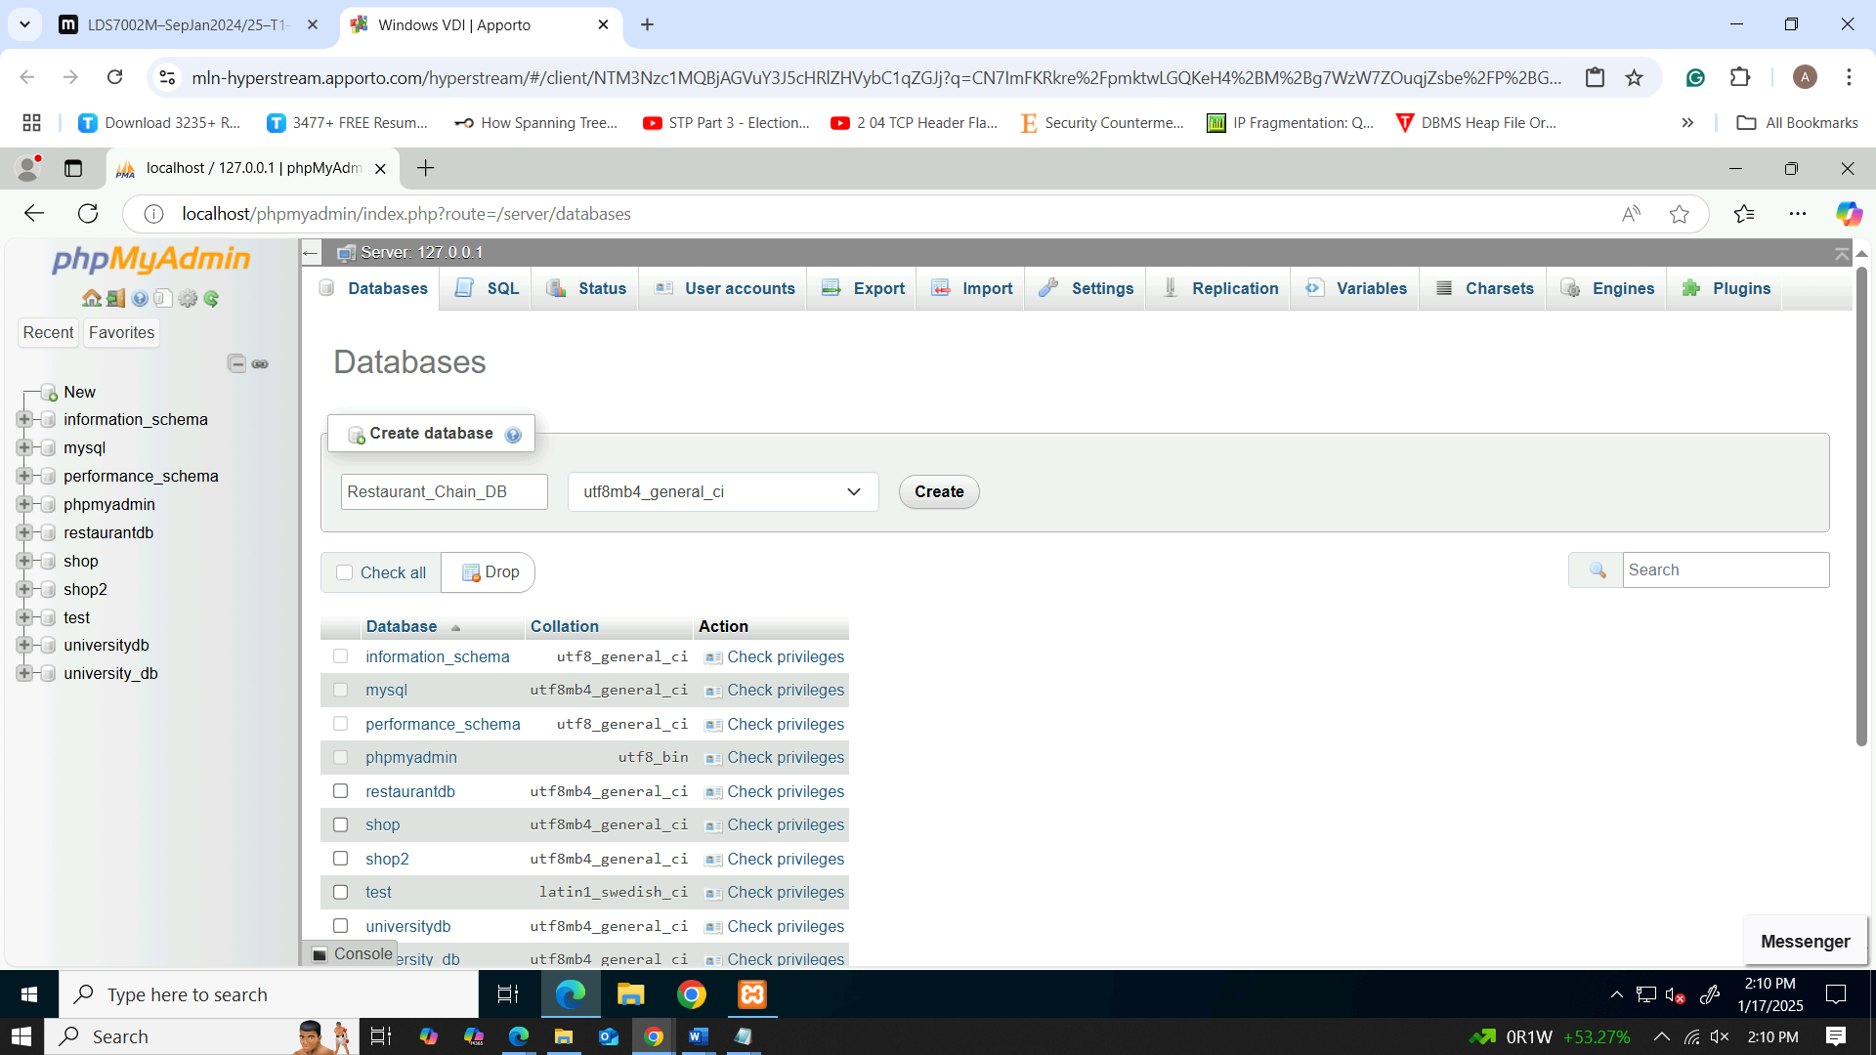

Figure 2: naming the database

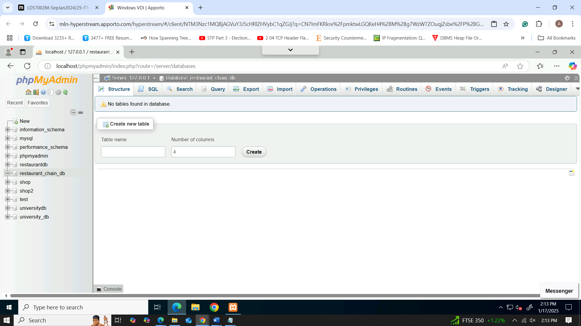

Figure 3: appearing of restaurant chain db database

Once a database is made, subsequent procedures are table creation where diverse data categories are grouped and setting relationships between tables for structure and load insertion into tables. Writing queries is a convenient way to indicate data acquisition and working with it, to guarantee the database’s compatibility with the application. This way, testing and optimization are conducted in order to keep the database competent for accomplishing its functions, with reasonable performance even under the varying workloads.

## Create Tables

### Customer table creation

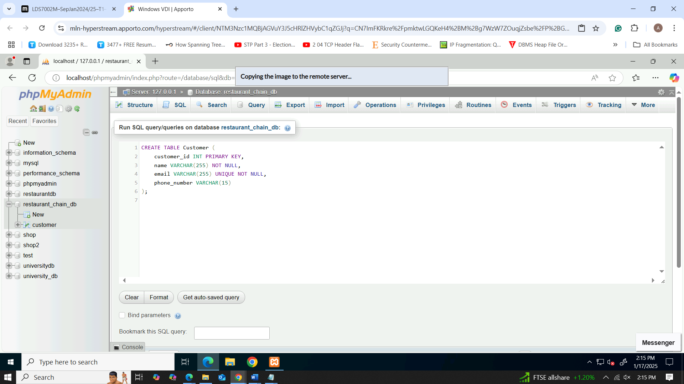

Figure 4: creation of customer table

### Category table creation

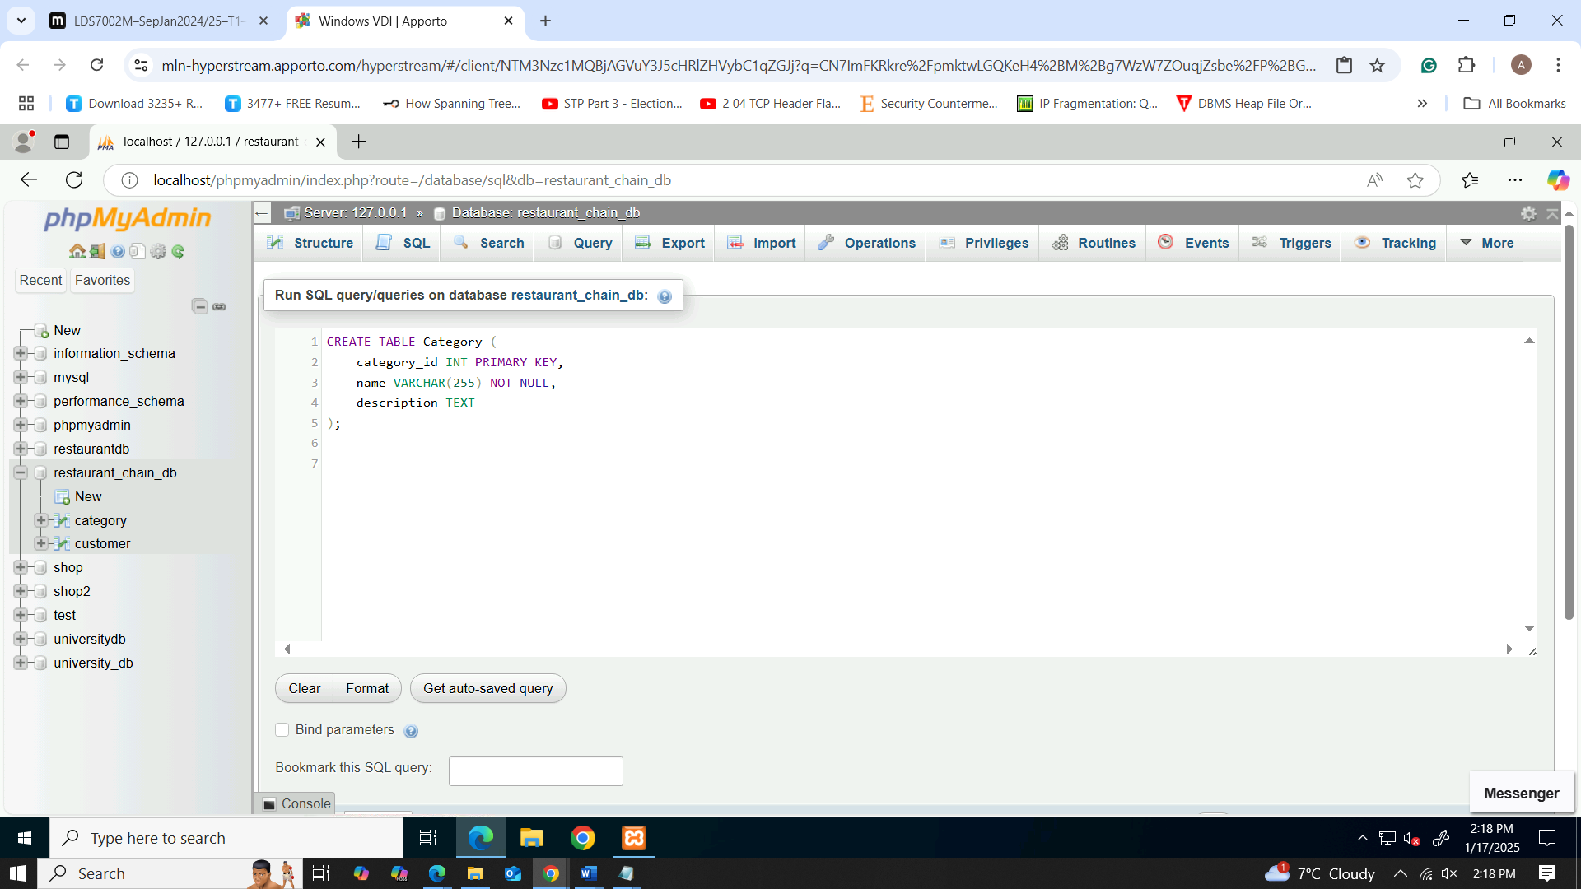

Figure 5: creation of category table

### Menu_item table creation

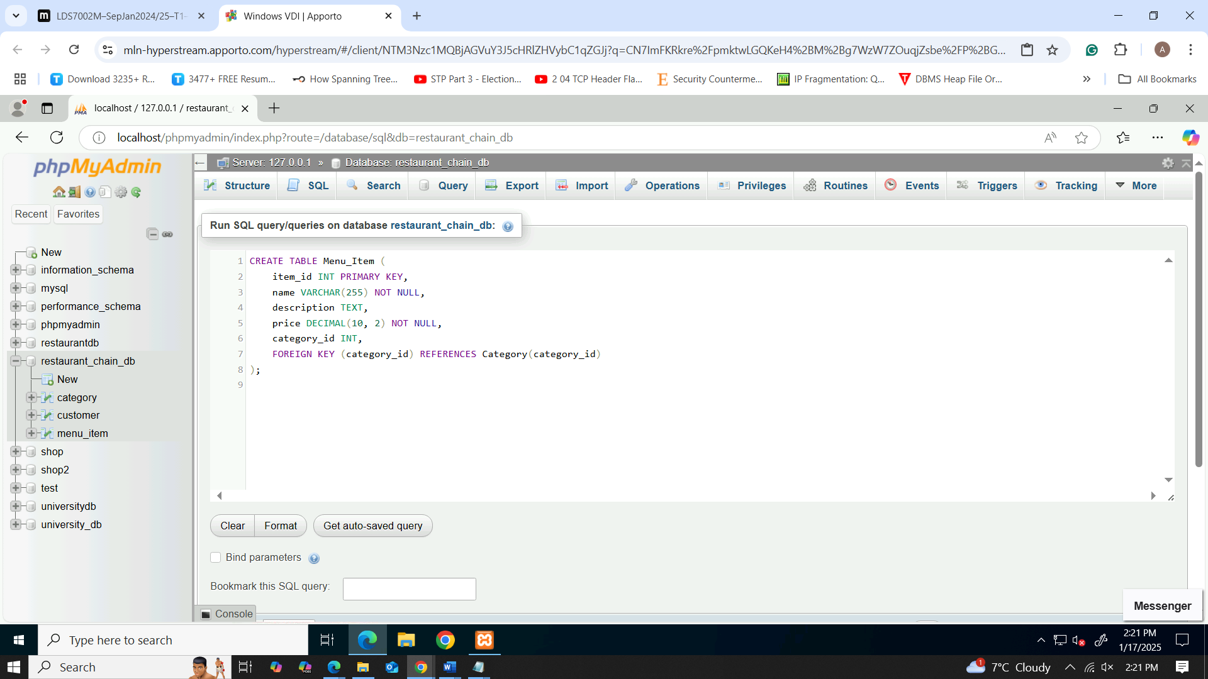

Figure 6: creation of menu item table

### Restaurant_location table creation

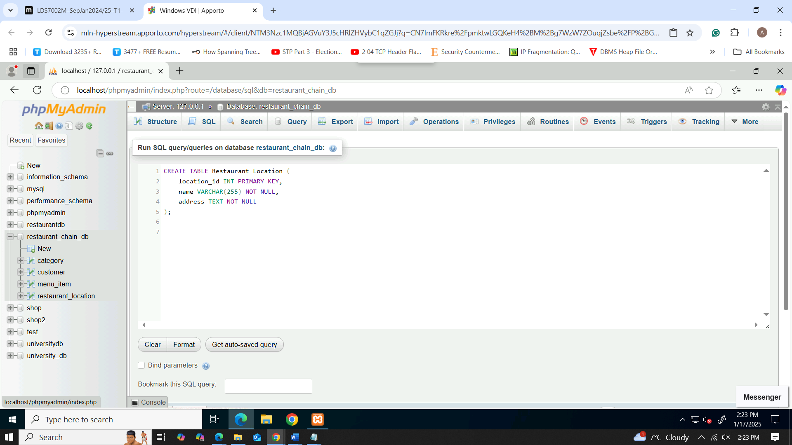

Figure 7: creation of restaurant location table

### Reservation table creation

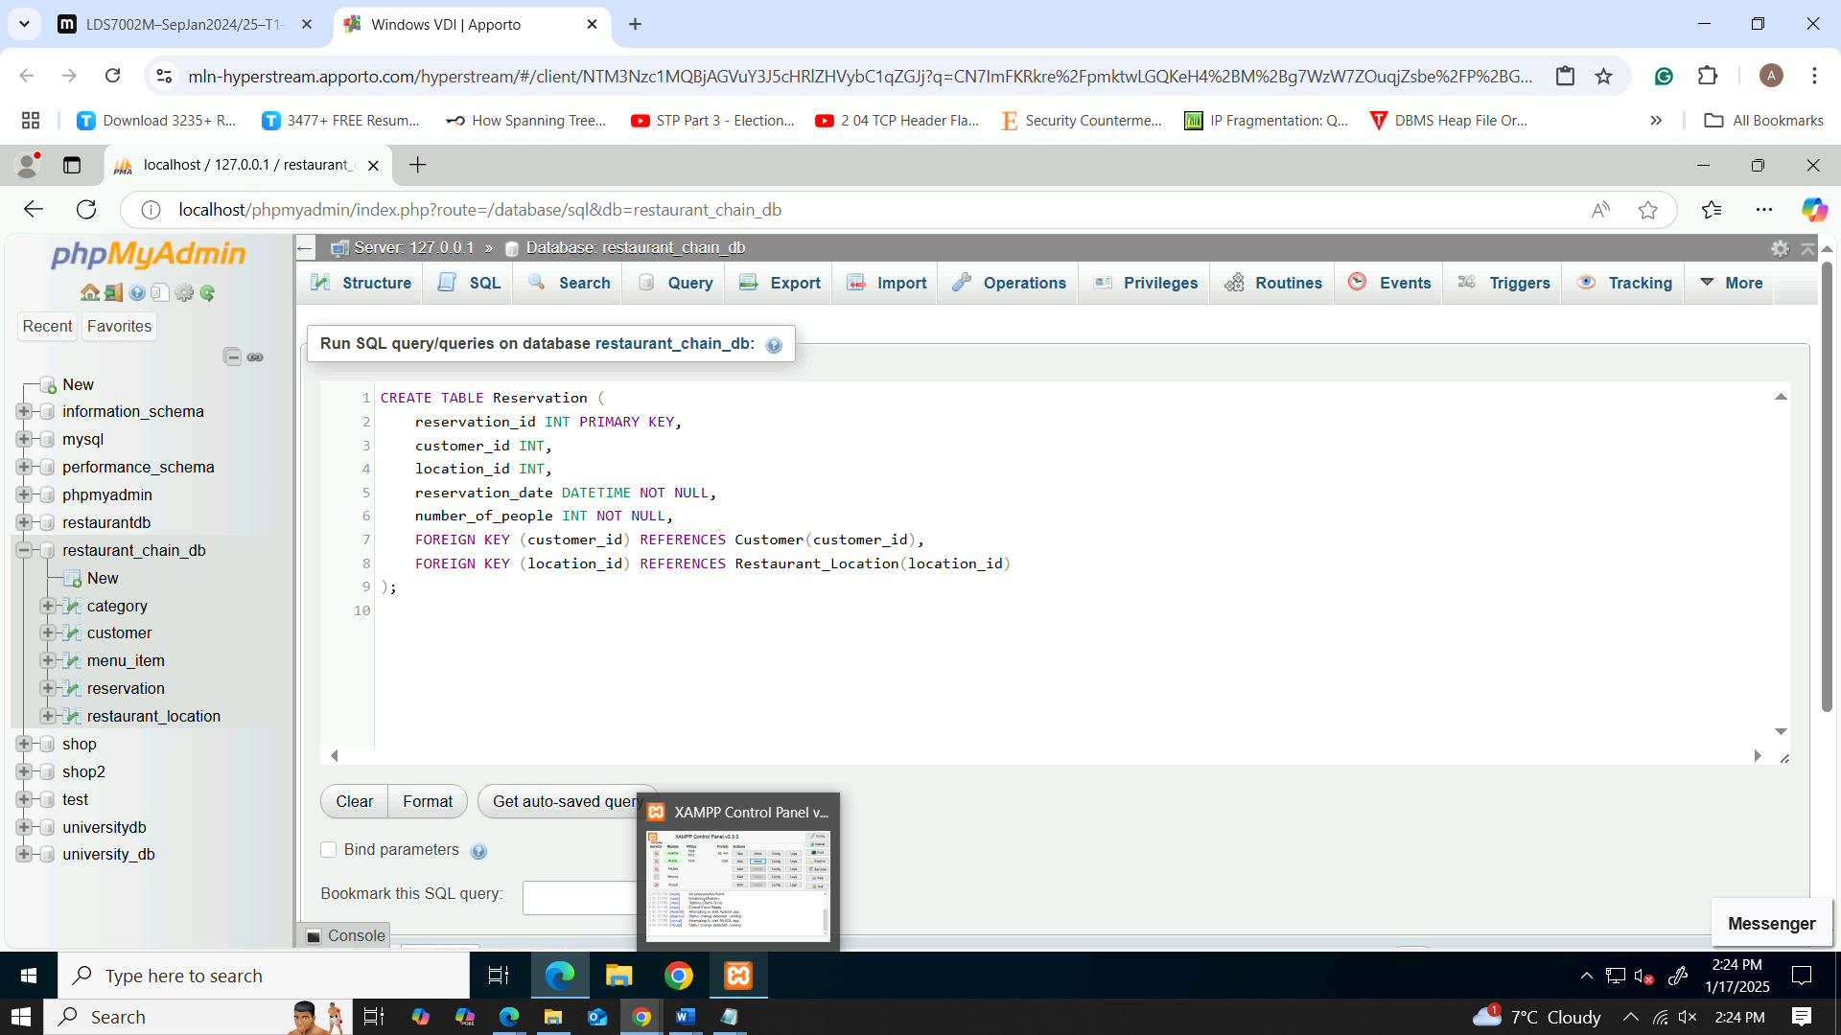

Figure 8: creation of reservation table

### Sales table creation

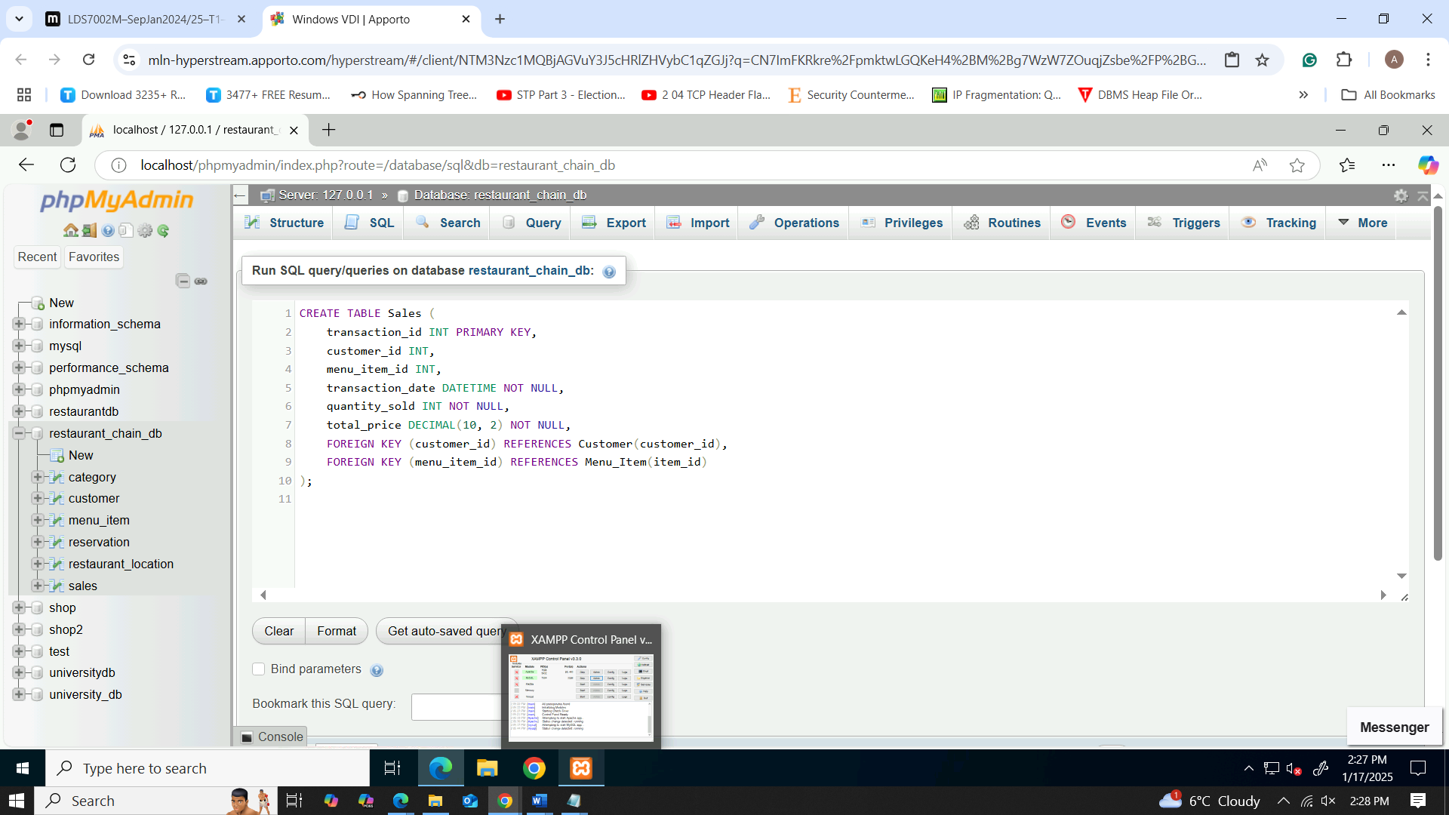

Figure 9: creation of sales table

### Ingredient Category table creation

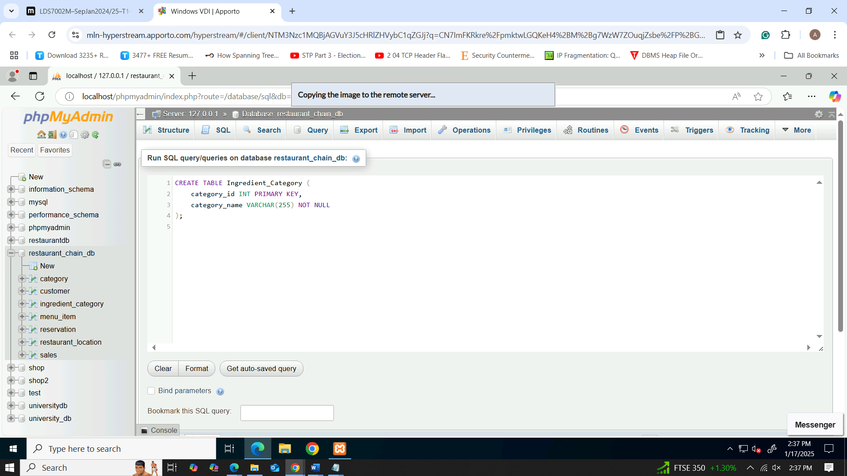

Figure 10: creation of ingredient category table

### Inventory table creation

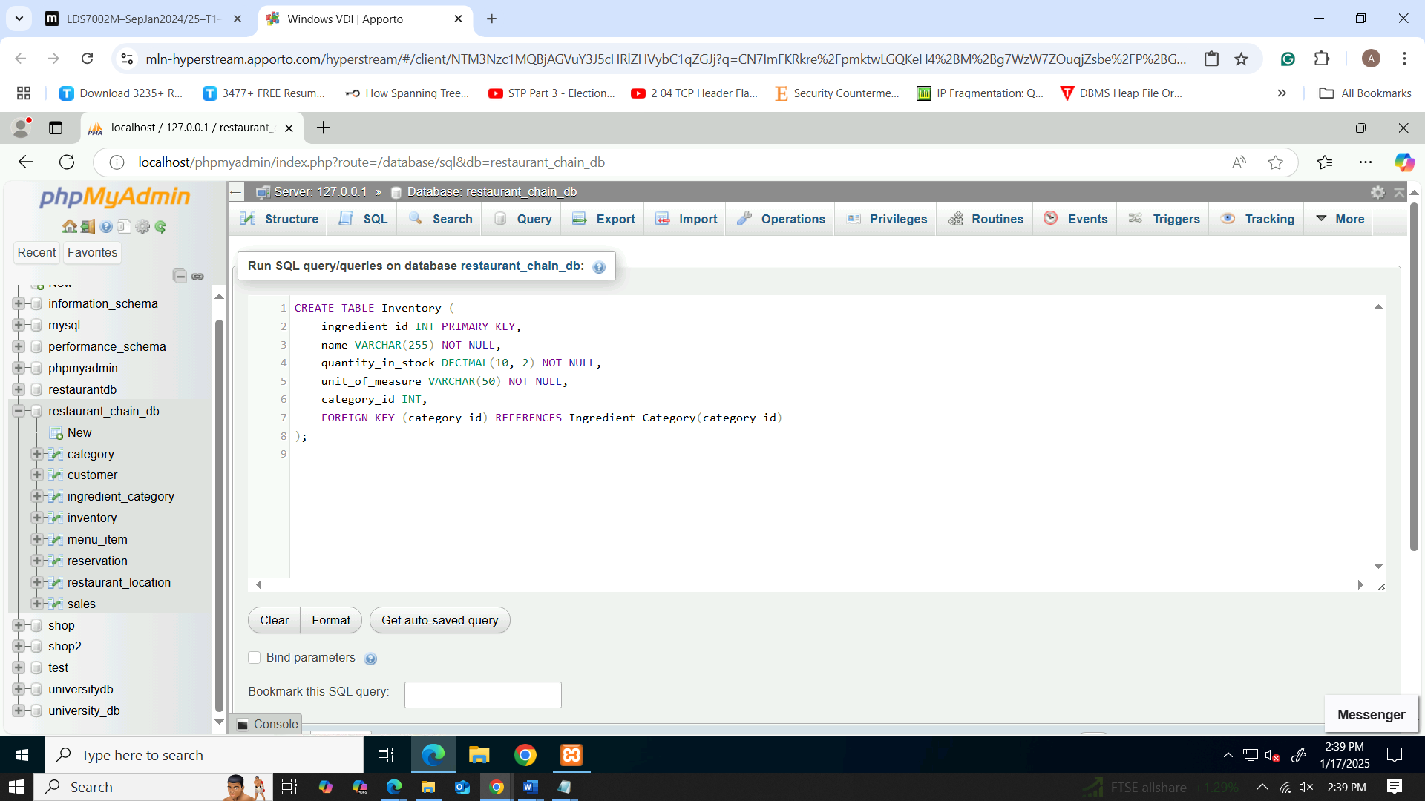

Figure 11: creation of inventory table

### Menu Ingredient table creation

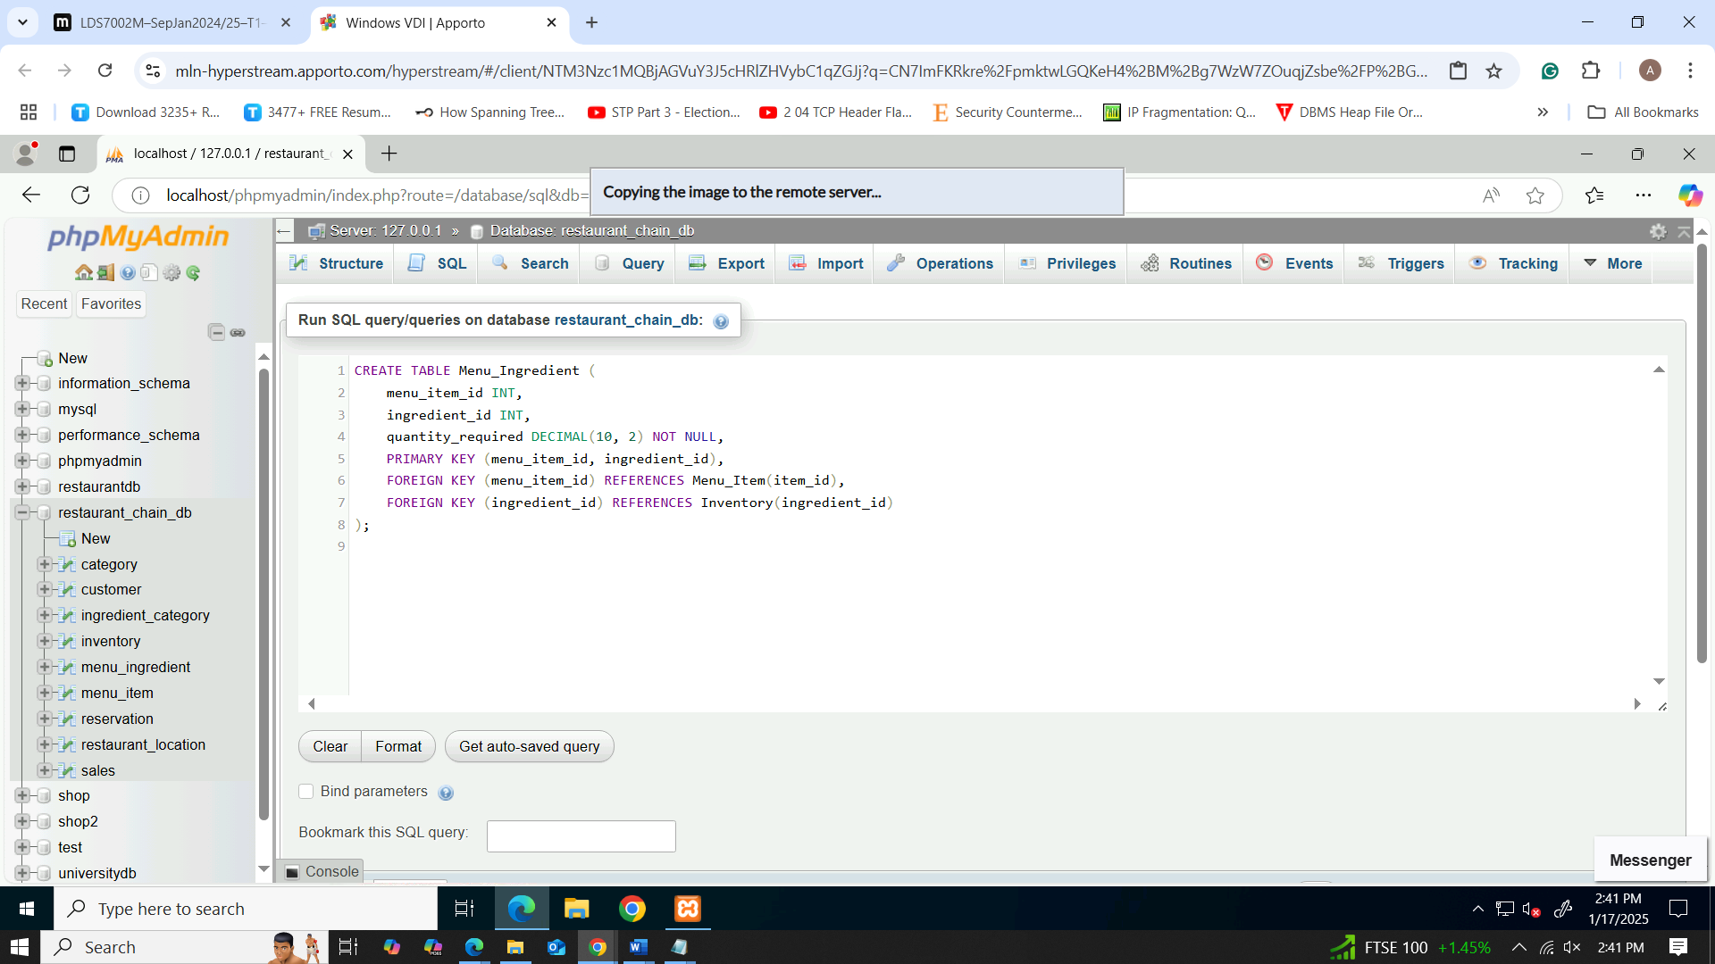

Figure 12: creation of menu ingredient table

### Employee table creation

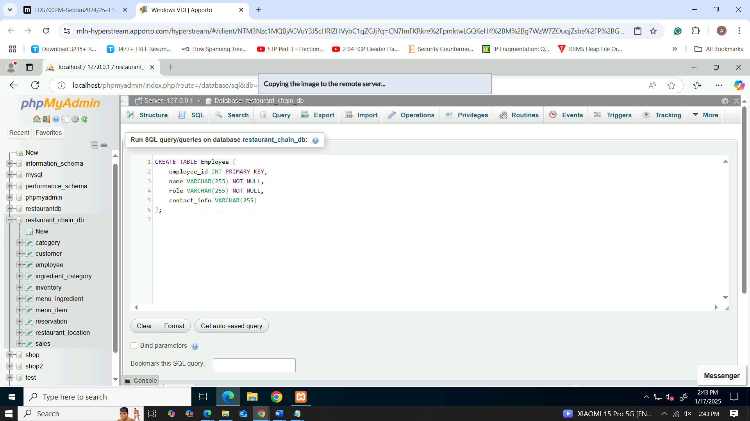

Figure 13: creation of employee table

### Shift table creation

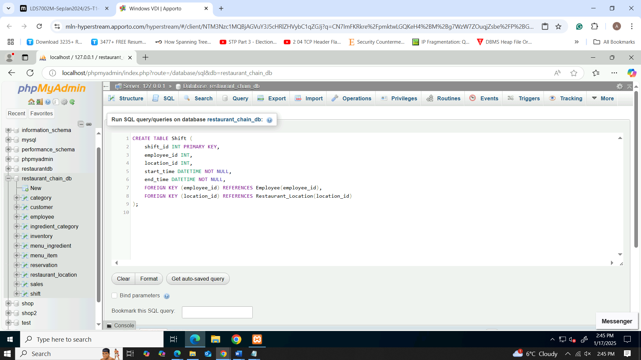

Figure 14: creation of shift table

### Supplier table creation

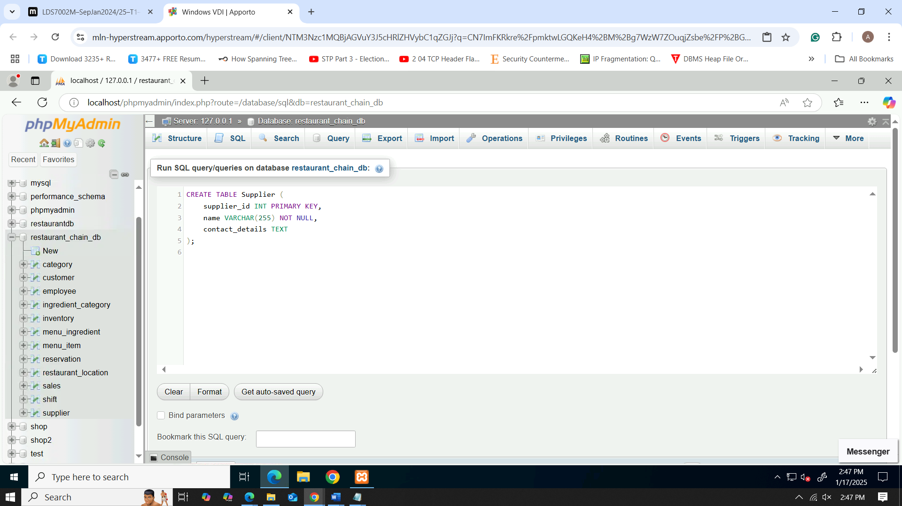

Figure 15: creation of supplier table

### Supply Order table creation

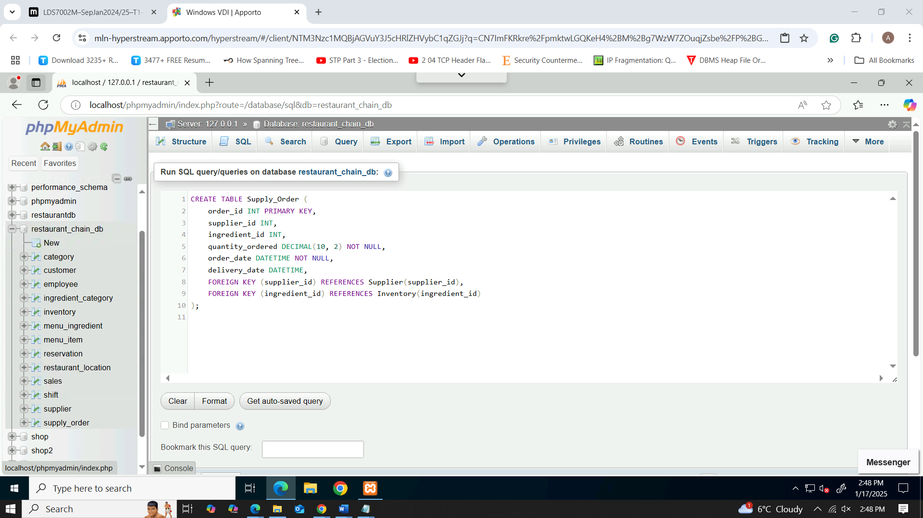

Figure 16: creation of supply order table

### Payment table creation

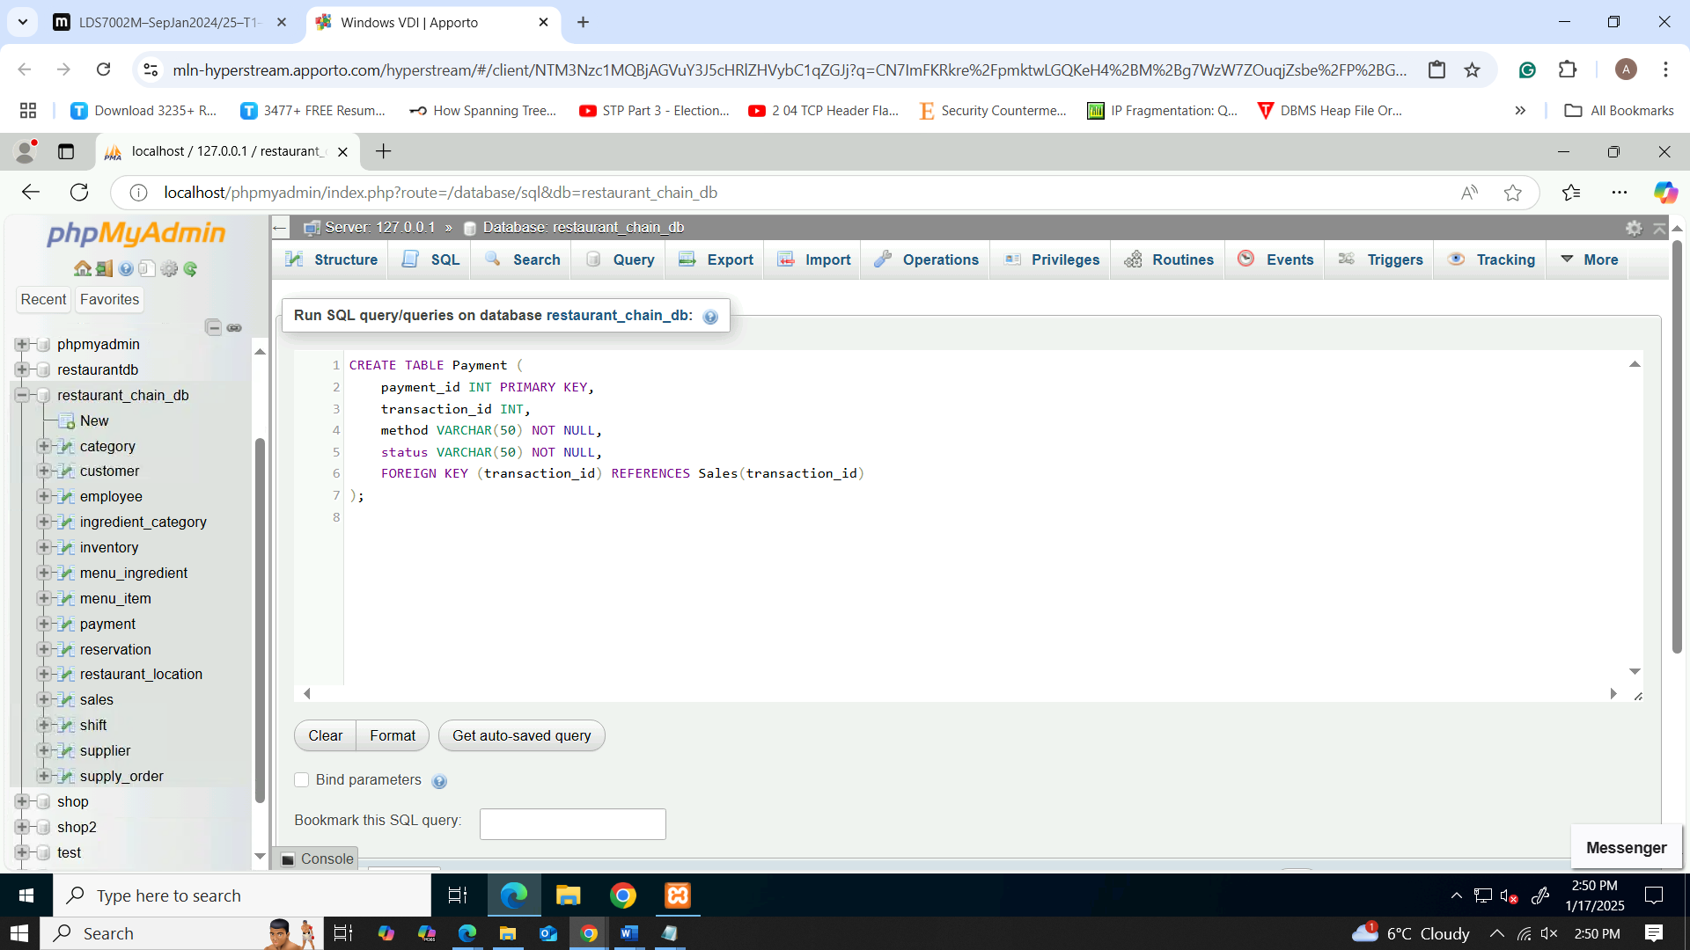

Figure 17: creation of payment table

### Feedback table creation

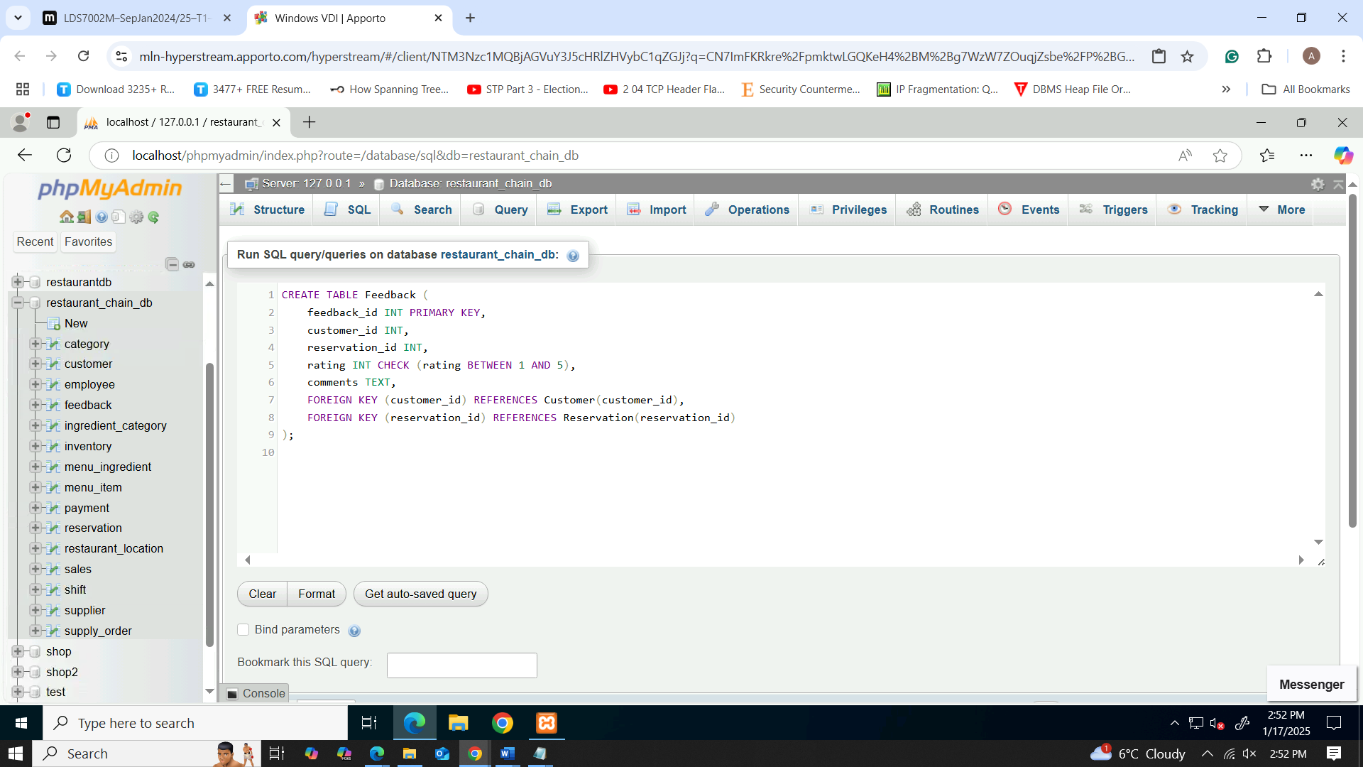

Figure 18: creation of feedback table

### Promotion table creation

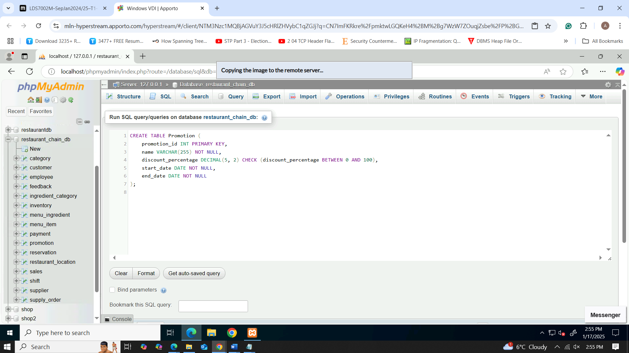

Figure 19: creation of promotion table

### Menu Item and Promotion junction table

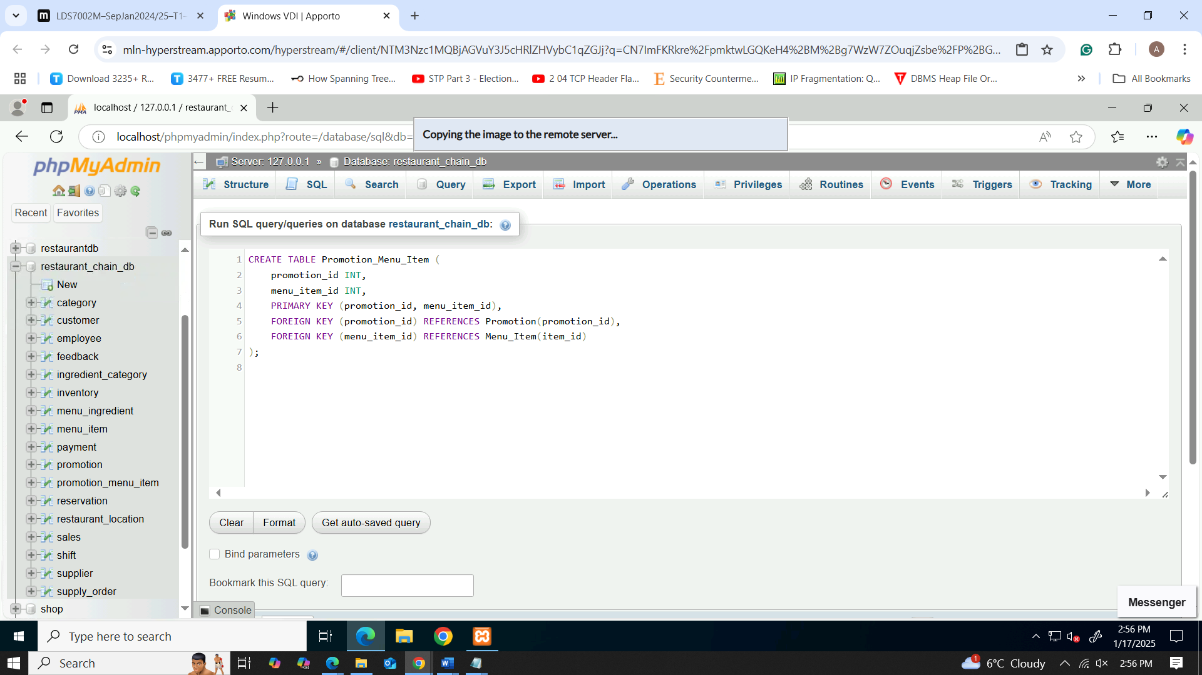

Figure 20: creation of promotion menu item table

## Value Insertion

### Customer data insert

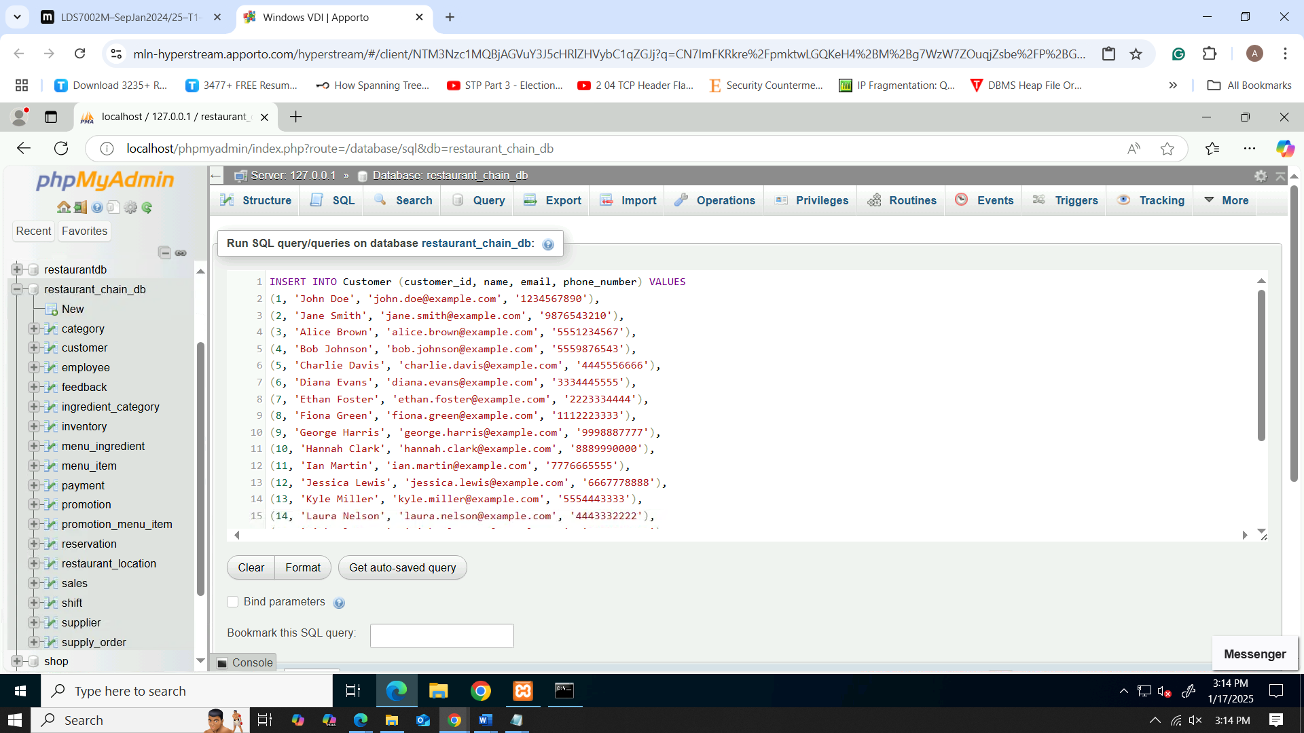

Figure 21: inserting customer data values

### Category data insert

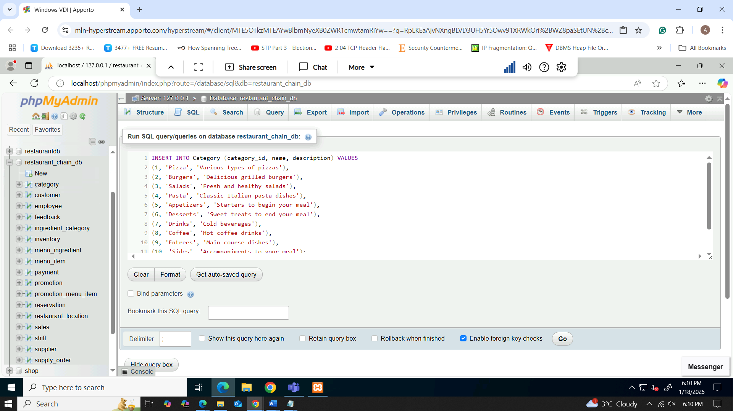

Figure 22: inserting category data values

### Menu_Item data insert

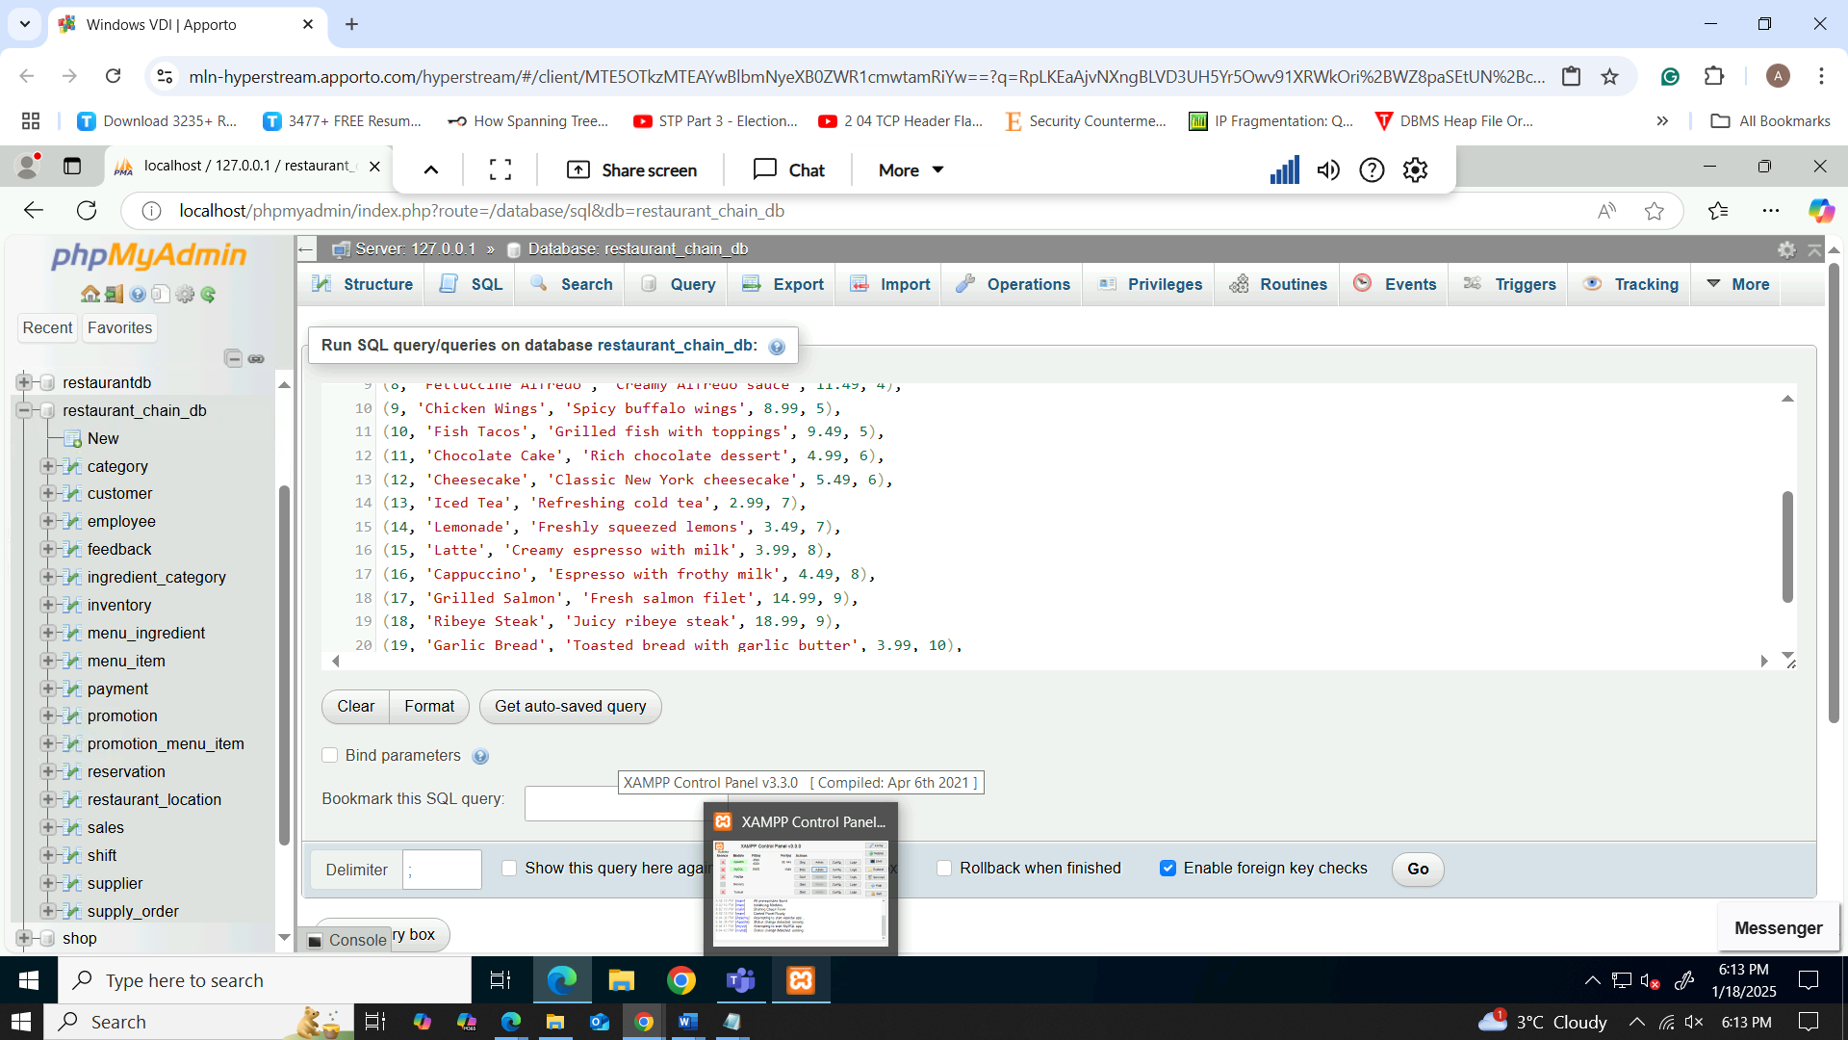

Figure 23: inserting menu item data values

### Restaurant location data insert

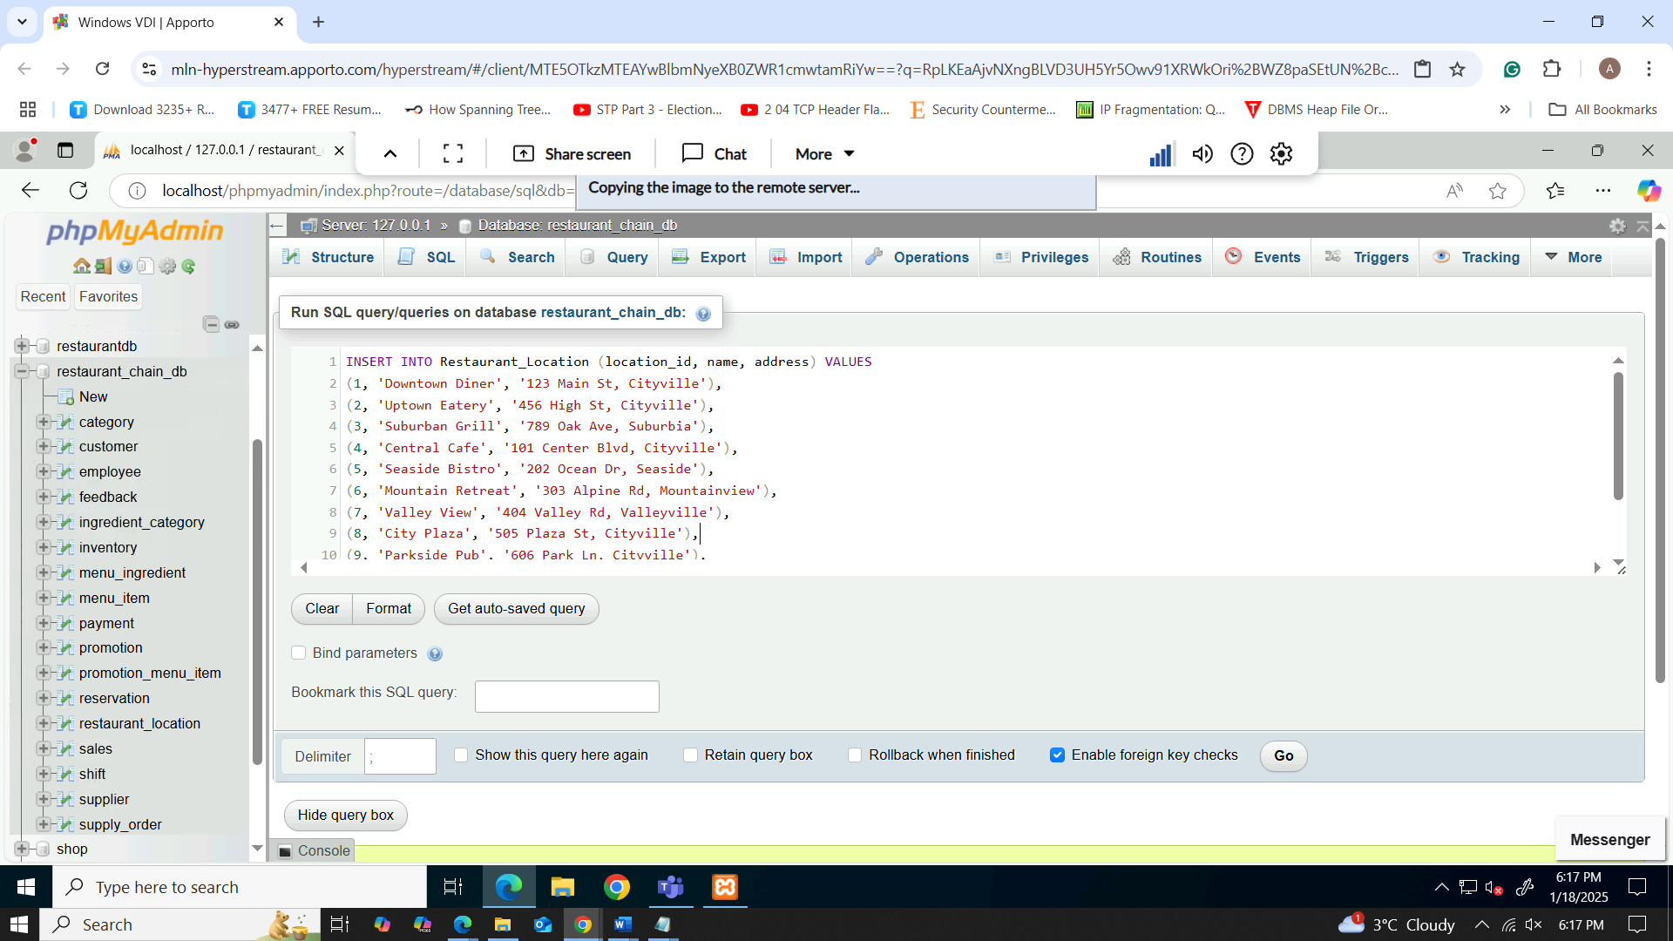

Figure 24: inserting restaurant location data values

### Reservation data insert

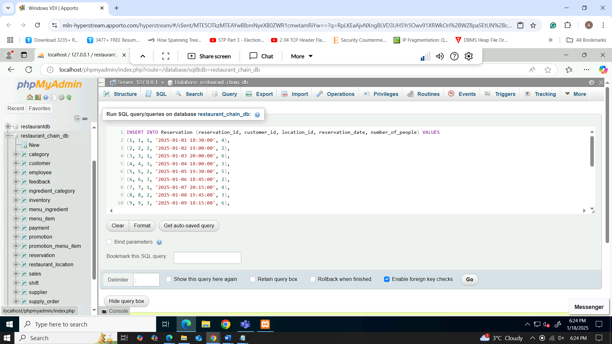

Figure 25: inserting reservation data values

### Sales data insert

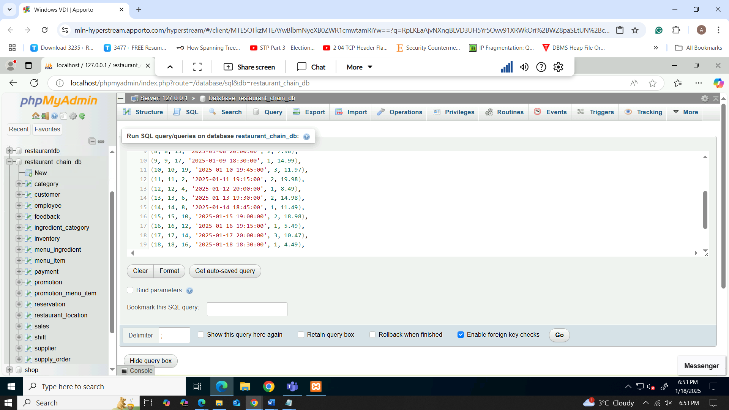

Figure 26: inserting sales data values

### Ingredient Category data insert

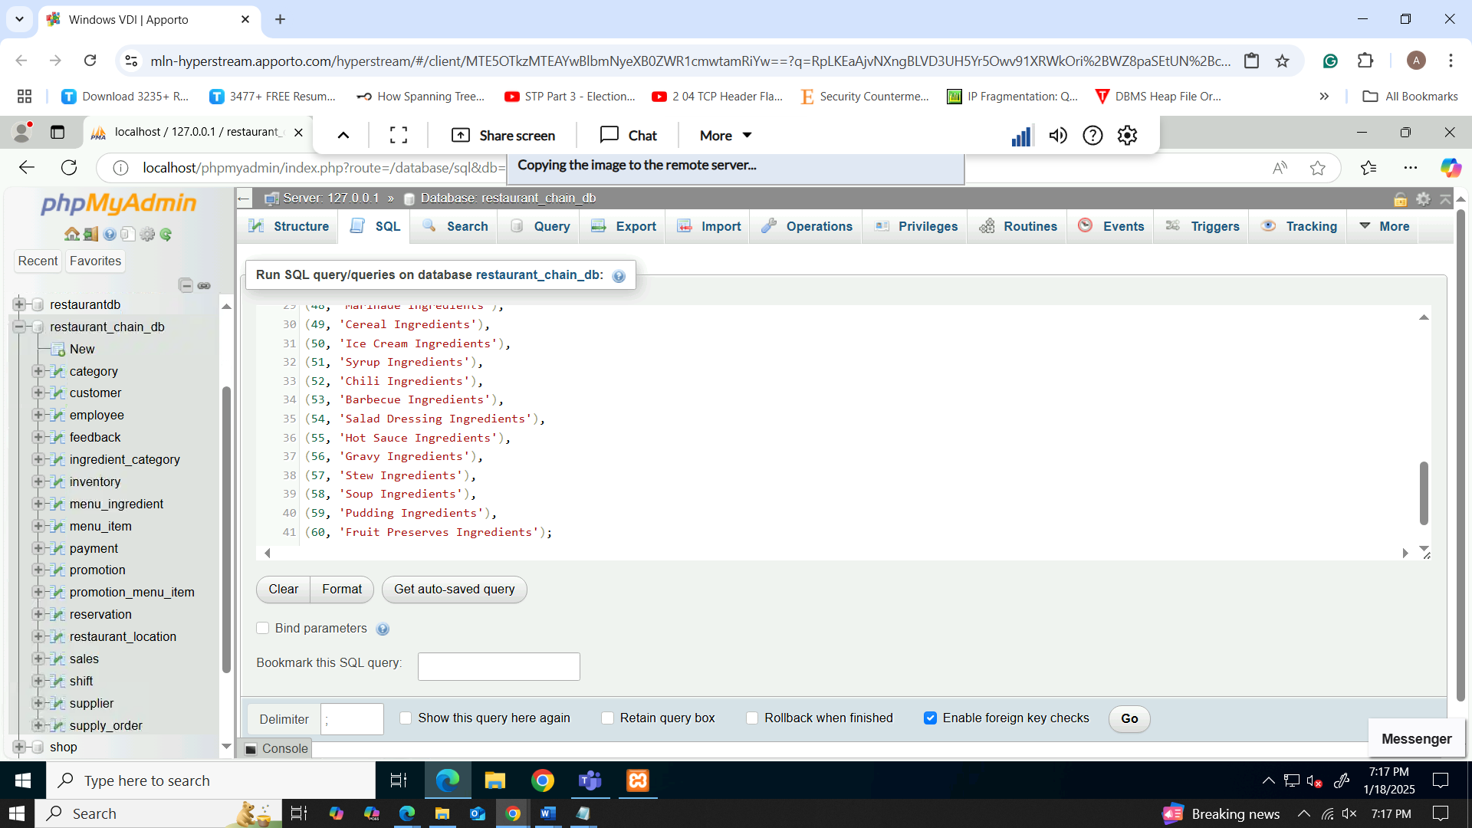

Figure 27: inserting ingredient category data values

### Inventory data insert

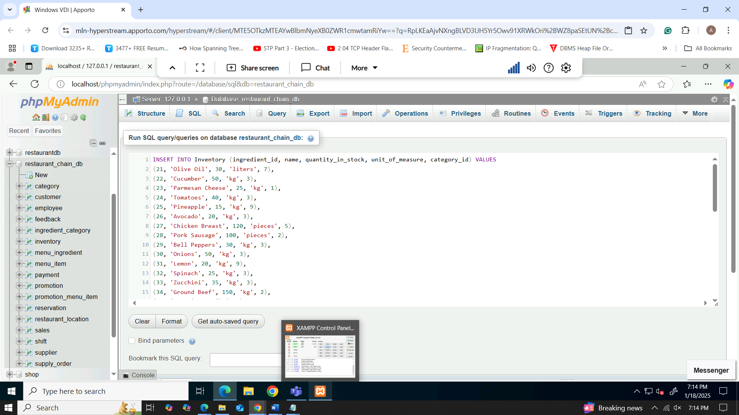

Figure 28: inserting inventory data values

### Menu Ingredient data insert

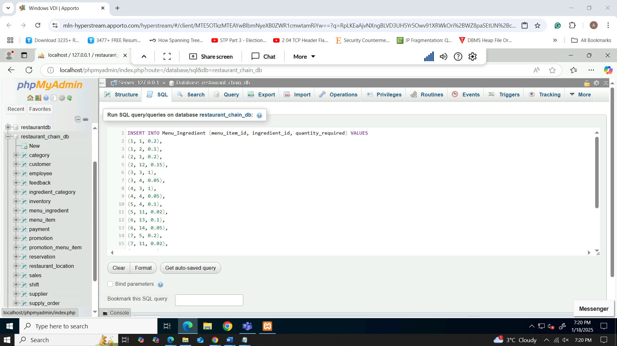

Figure 29: inserting menu ingredient data values

### Employee data insert

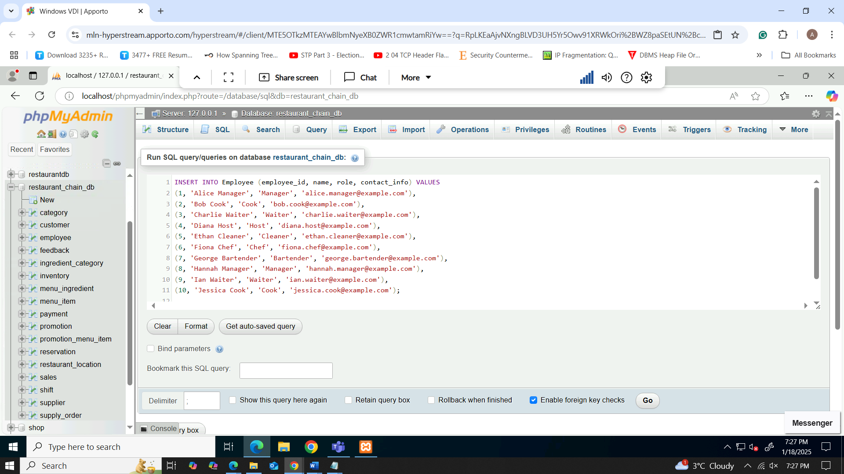

Figure 30: inserting employee data values

### Shift data insert

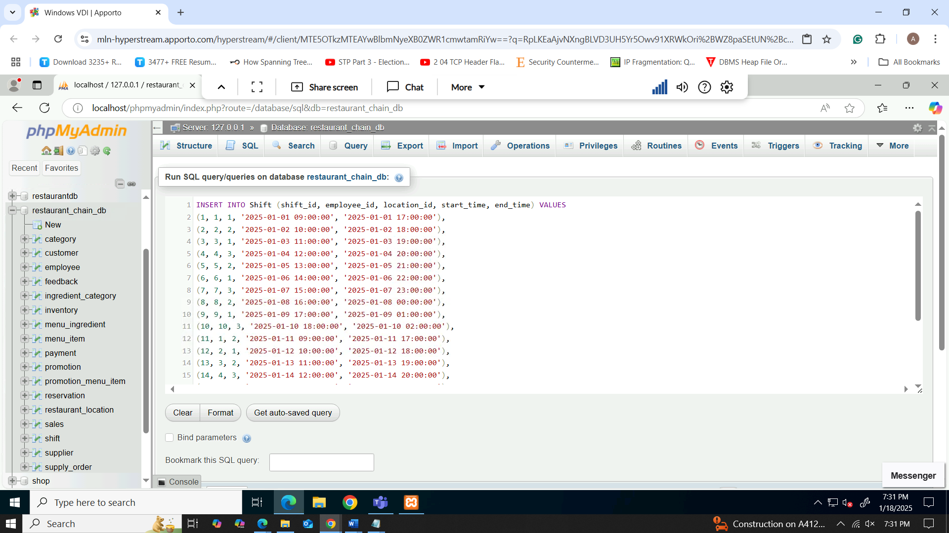

Figure 31: inserting shift data values

### Supplier data insert

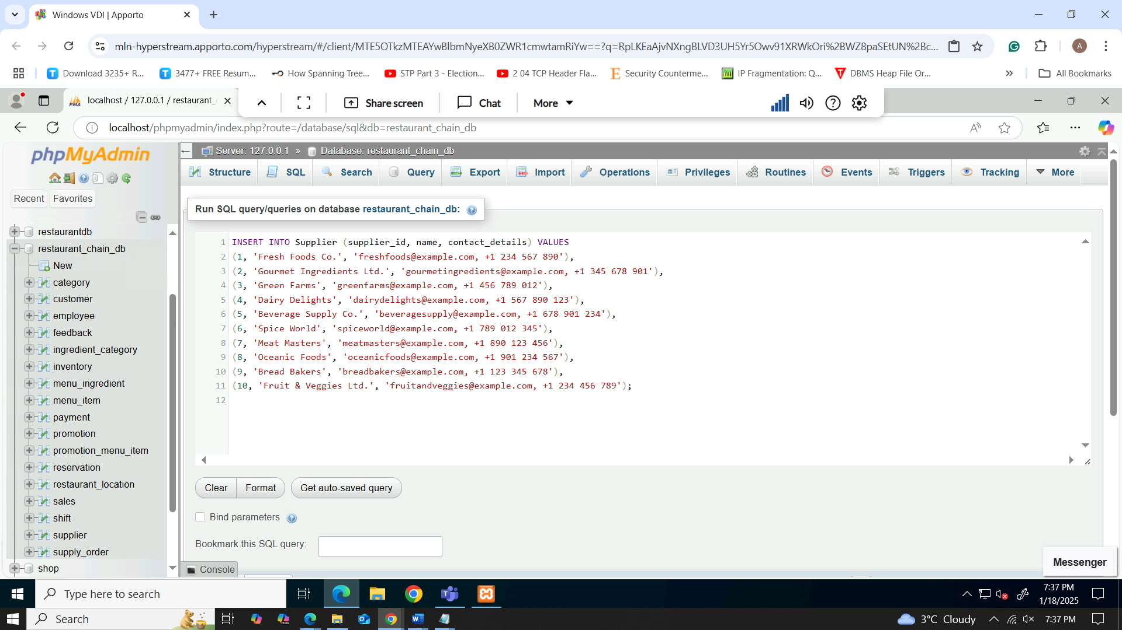

Figure 32: inserting suppler data values

### Supply Order data insert

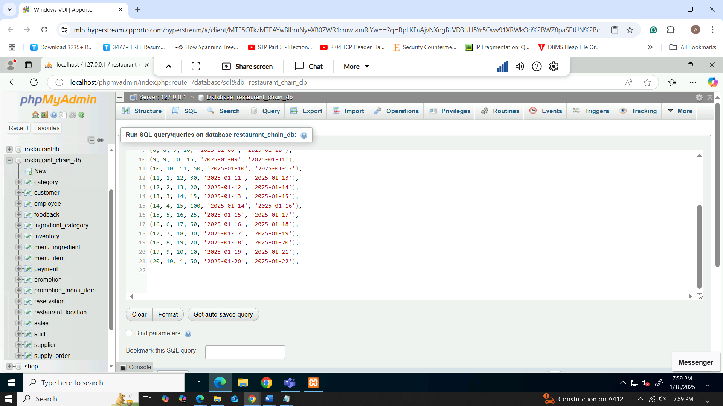

Figure 33: inserting supply order data values

### Payment data insert

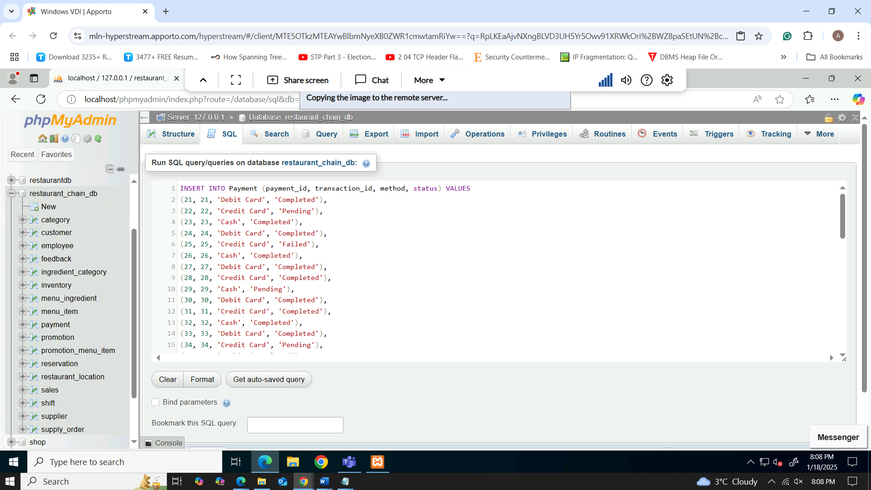

Figure 34: inserting payment data values

### Feedback data insert

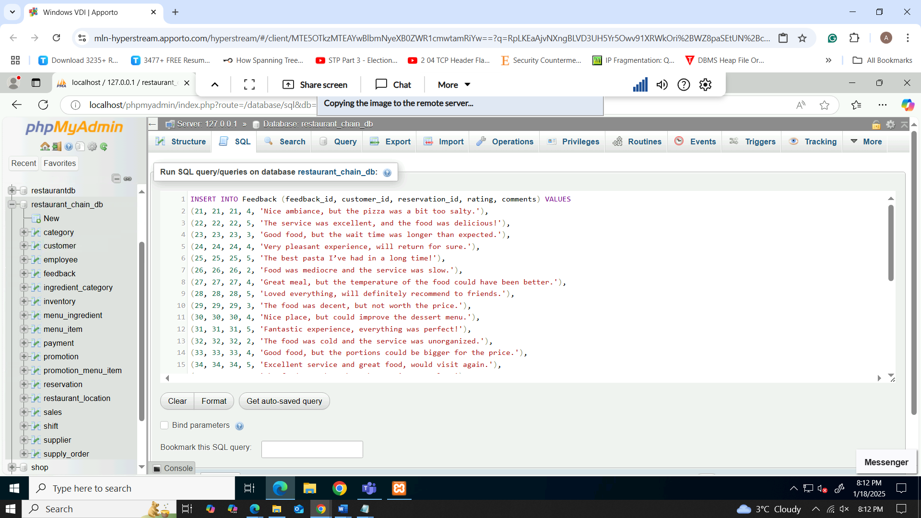

Figure 35: inserting feedback data values

### Promotion data insert

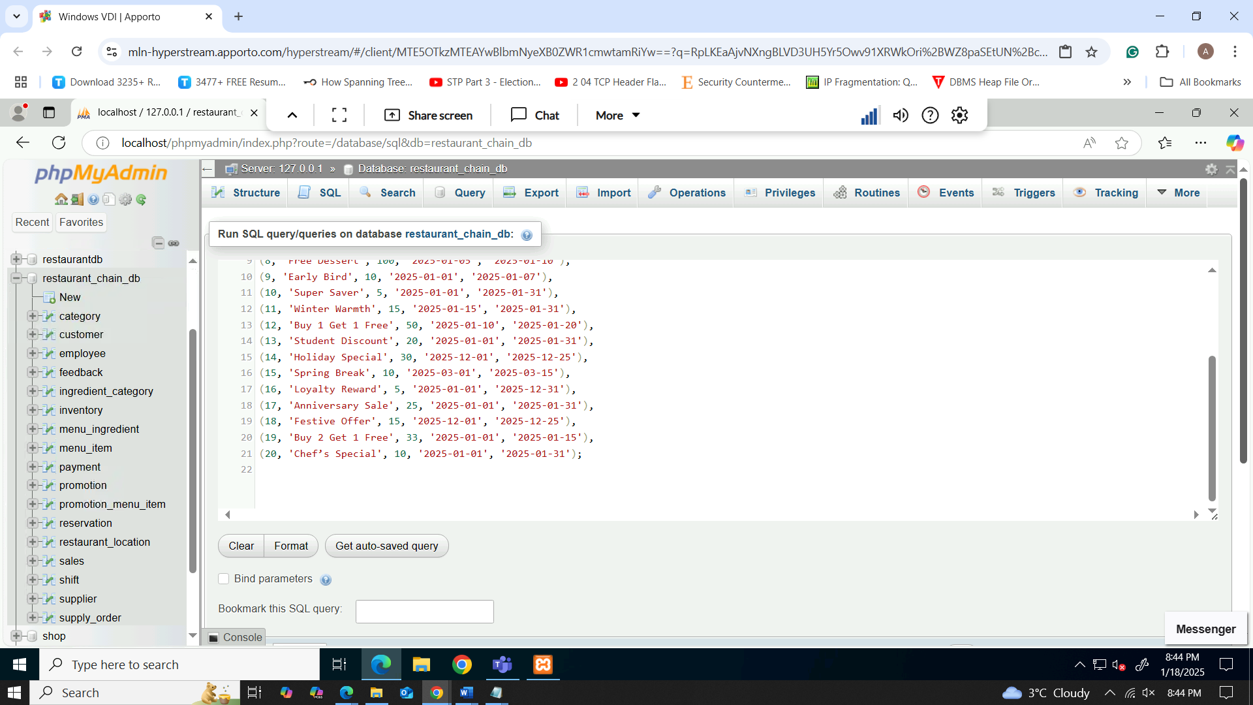

Figure 36: inserting promotion data values

### Promotion_menu_item data insert

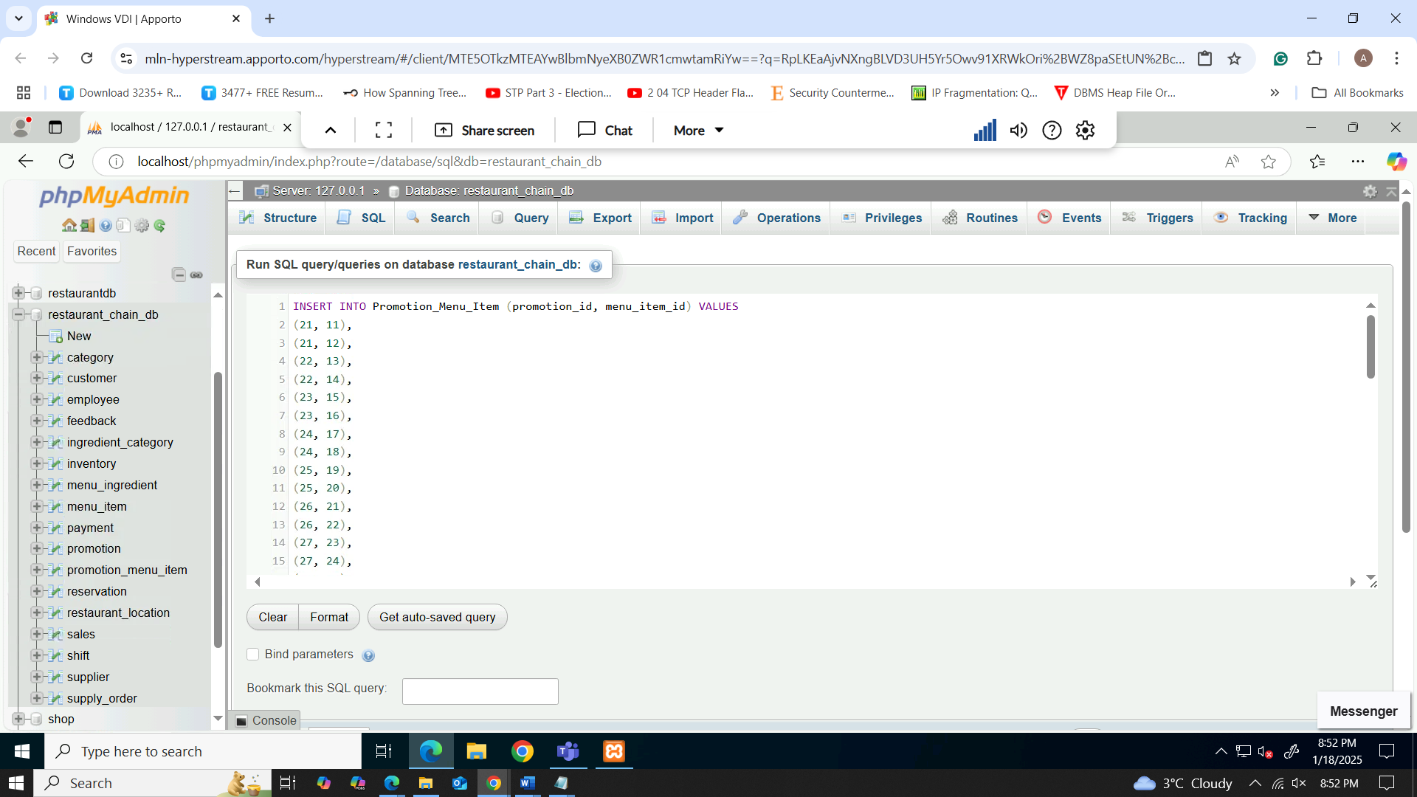

Figure 37: inserting promotion menu item data values

# Query Development

* Total menu discipline for the different menu categories over a given date

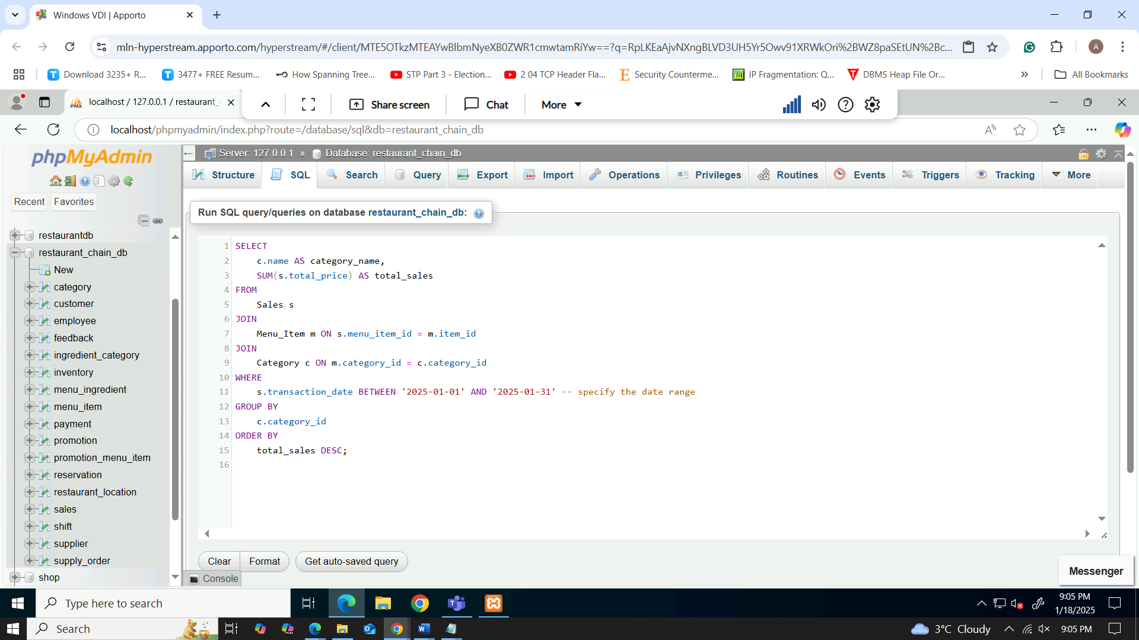

Figure 38: Total sales for each menu category

For execution of this query, data is accumulated from the Sales, Menu_Item, and Category tables and the total sales for each category of the menu is determined within a given time period. First it links Sales with Menu_Item by joining with menu_item_id and then Menu_Item and Category join the sales database by joining with the category_id. Sum calculates the total or probably ‘total_price’ for each category the result has been recommended to be filtered by the date range of from January 01 2025 to January 31 2025. The results contain the information grouped by category_id and ordered by the total sales in descending order. The output gives the list of all the available categories and total value of all the products in that particular category.

The query results as depicted in the excel files highlights the total of the sales of every menu category between 1st January 2025 and 31st January 2025. Every row contains the name of a category and the total amount of sales in that specific category that was obtained by summing up the total amount of all foods belonging to that category. Different categories are ranked according to the level of sales made within this period with subcategories that recorded the highest sales highlighted as follows.

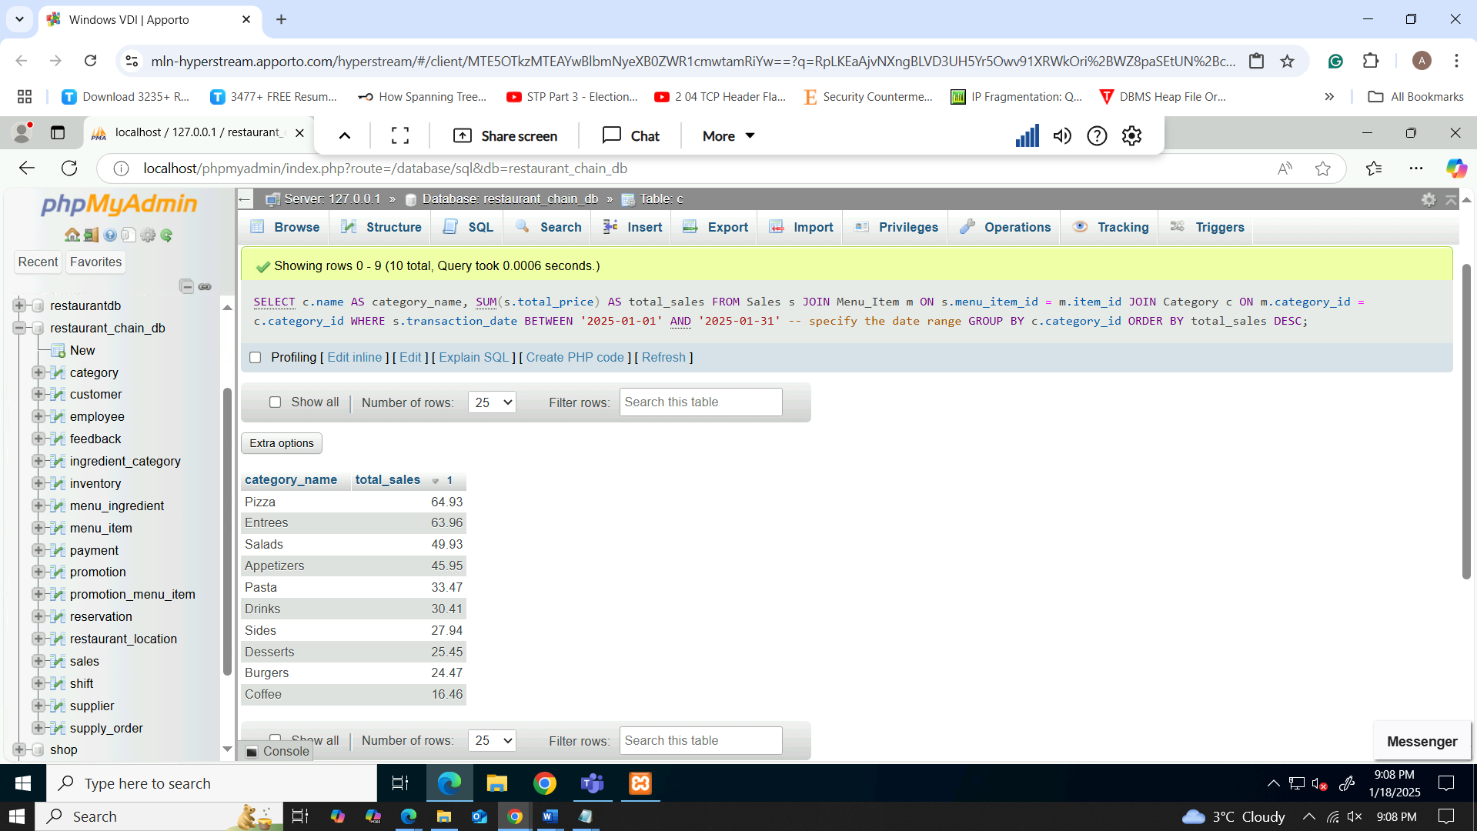

Figure 39: results of Total sales for each menu category

* Ranking of a total of 10 most ordered foods for specific days with breakdowns of name and type of food, total quantity sold

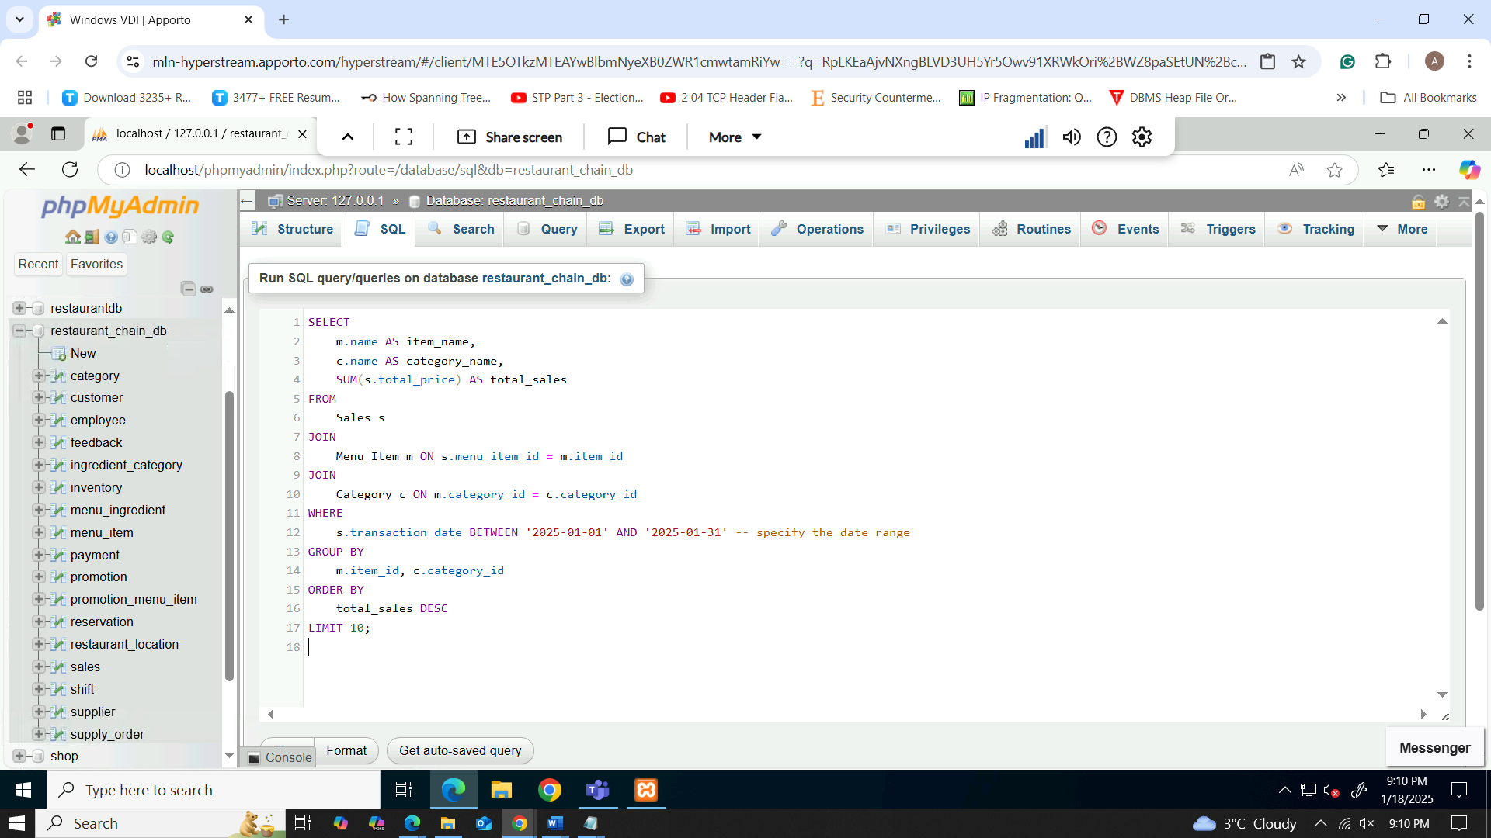

Figure 40: Top 10 most popular menu items

This query determines average sales of items per day then list the 10 most ordered meals up to the January 31, 2025. This connects you with the Sales table in menu_item_id in the Menu_Item table; then Menu_Item table in the category_id in the Category table. SUM just sums the total_price of each item, with a GROUP BY of item_id and category_id to group the entries by each menu item. The results contain the name of the menu item, the category name, and the total amount of sales made which belongs to the category. The query orders the results in order of total sales in descending order, and then only splits the first ten items, giving an overlook on the most popular items in the menu for the period in question.

In the output of the query below, the ten most ordered meals by the total amount of sales during the period 1/1/2025 to 31/1/2025 are shown. Every row shows the name of the menu item, it’s type, and the total revenue within that period of time. The obtained results are ordered from the highest to the lowest level of sales placed at the top which is significant when the revenue for specific menu items during the given period is to be analyzed.

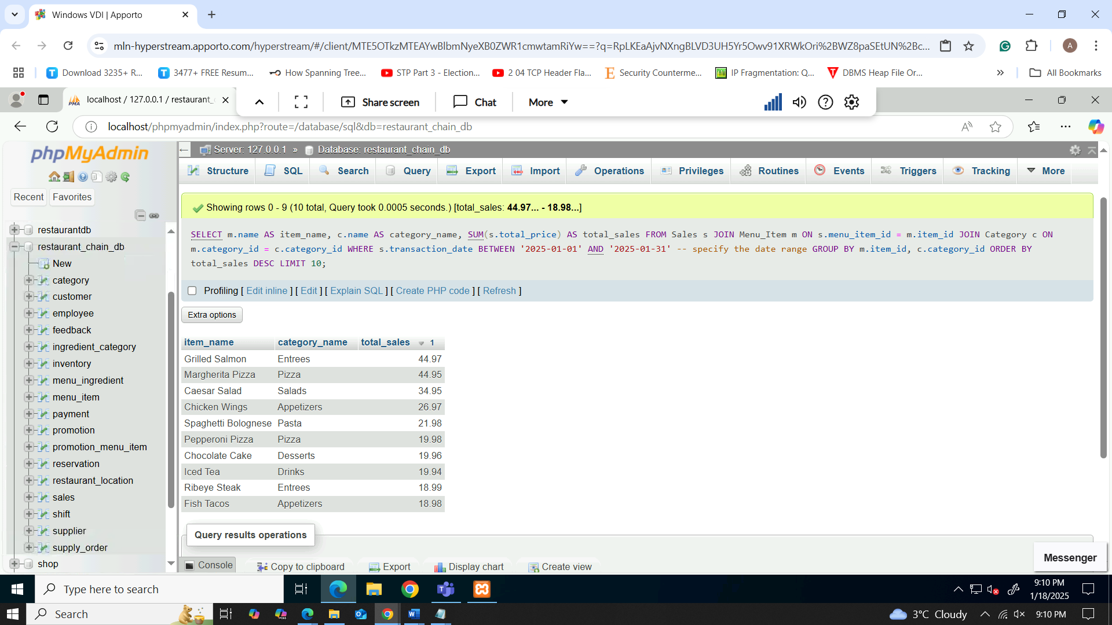

Figure 41: results of Top 10 most popular menu items

* Order information with the customer’s first name and last name, phone number, number of bookings made within the last 30 days

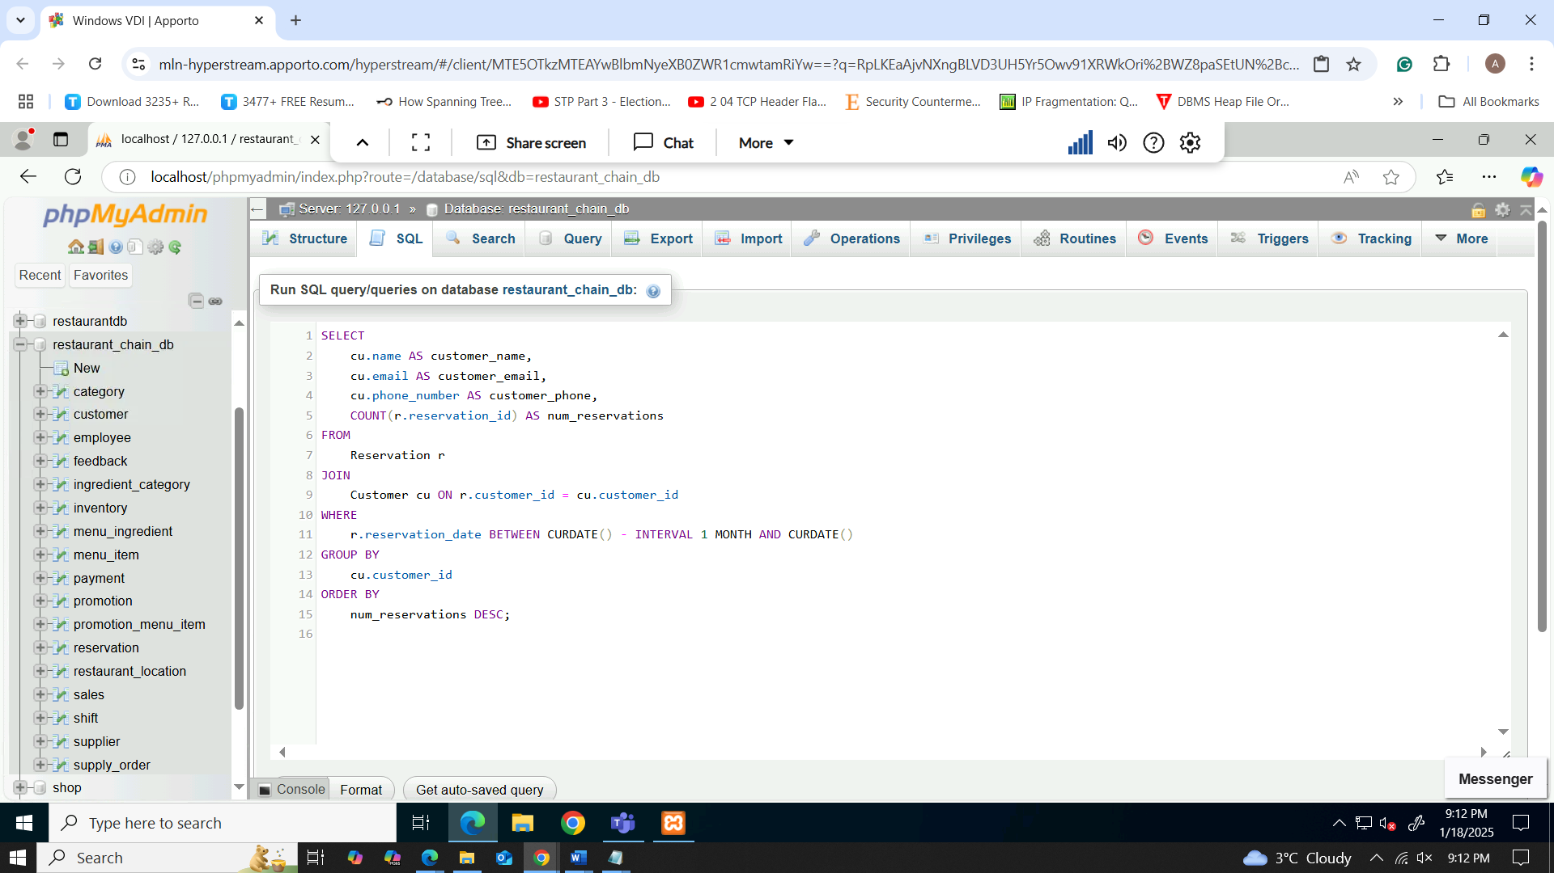

Figure 42: Customer reservation history

The use of this query lets you view a reservation history of customers who booked some table within the last one month, contains the name, email, phone number of customers, and the number of total reservations made by the customer. It associates the Reservation table with the Customer table with the use of the customer_id to connect customers with their reservation. The COUNT function again counts the number of reservations a certain customer has made and this is limited to the current month’s reservations with the aid of CURDATE() and INTERVAL 1 MONTH functions. The result set consists of distinct customers, ordered in descending order of the number of reservation and presented with a row for each customer ID.

The generated query shows customers who made some reservations in the last one month with their name email number or phone total reservation. Every row is a customer identified by the unique number, but all rows belong to a single table. The number of reservations is obtained by COUNT and the output is ranked based on the number of reservations given a start date and an end date of the customers’ visits.

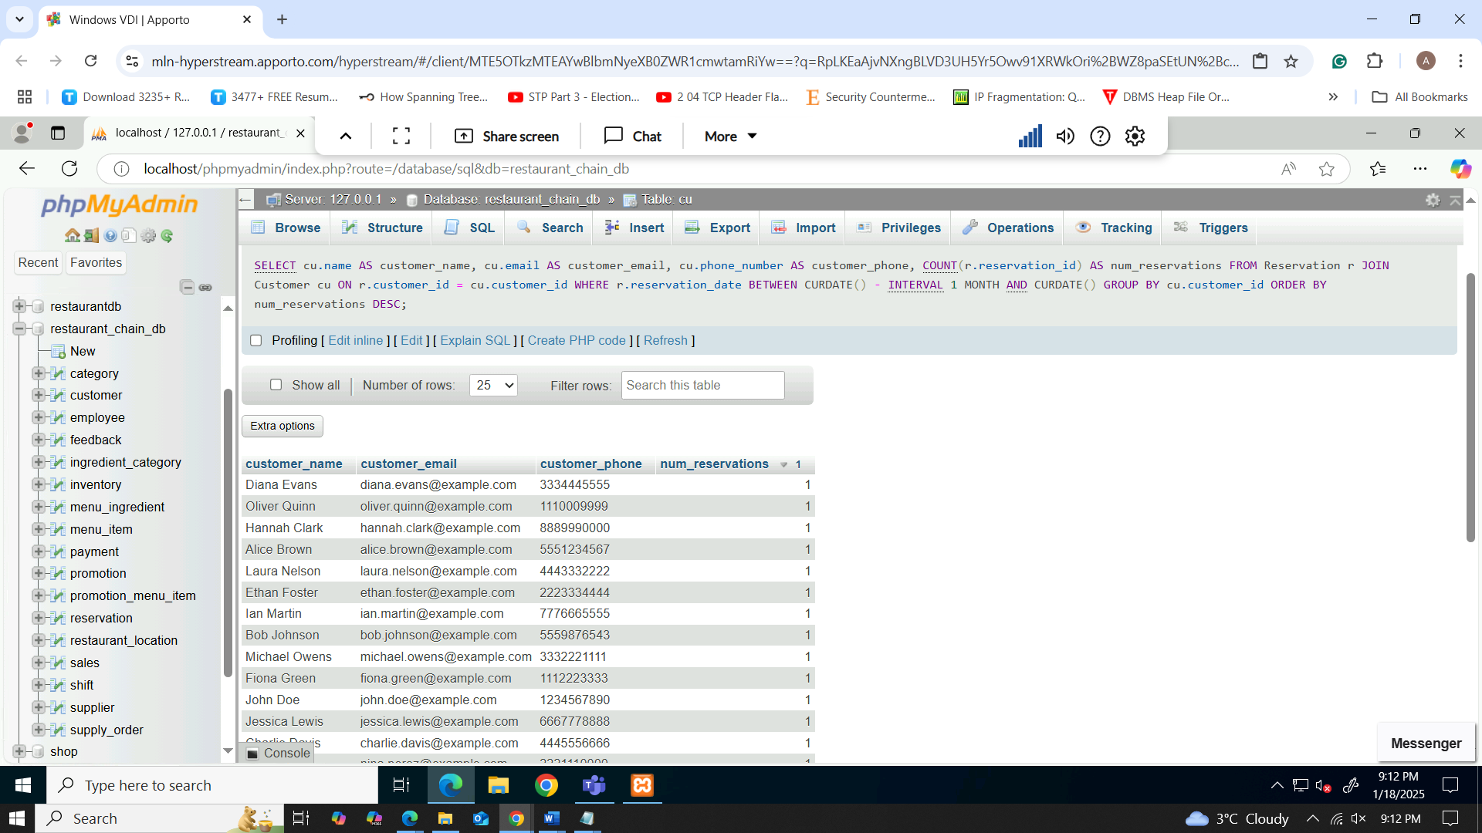

Figure 43: results of Customer reservation history

* Basic stock position of each ingredient: The ingredient name, the type of ingredient, and the amount it is currently in store.

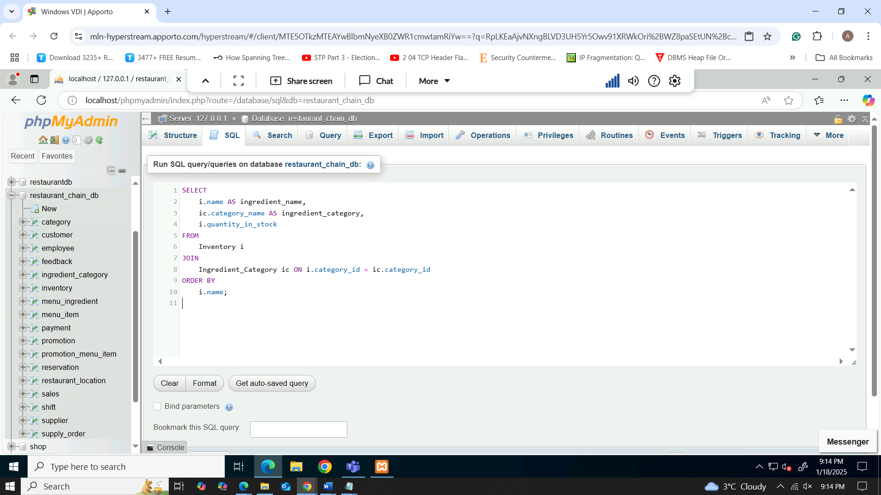

Figure 44: Current inventory levels by ingredient

This query gives the specific quantities of each of the ingredients on the various categories, name of the ingredient, and the quantity in stock now. It relates Inventory table with Ingredient_Category table with category_id as a reference that connect every ingredient in the inventory to the category of ingredients. This is because the selected columns are simply name of the ingredient, name of the category it belongs to and quantity of item in stock to give a clear picture of inventories. These results are ordered according to ascending values of ingredient name (i.name for enhanced results legibility. This query is useful to explain the quantity of stock on the ingredients of the normal list and also to know in which category they belong to.

The query output is a list of the ingredients along their names, their categories and the stock at the current moment. The results are arranged from A to Z according to the ingredients’ names thus makes it easy to find ingredients and to check the possibility of their availability. This was especially useful infinding out more about inventory and the proportionate distribution of stock by category of ingredients.

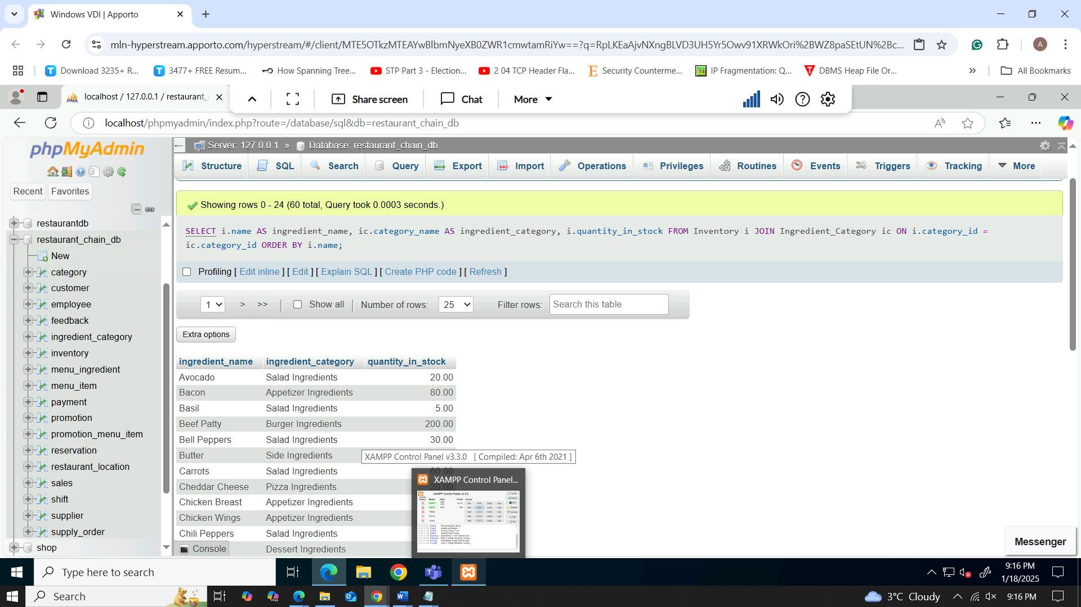

Figure 45: results of Current inventory levels by ingredient

* The total amount of money earned by each restaurant location in the past year along with the name locations

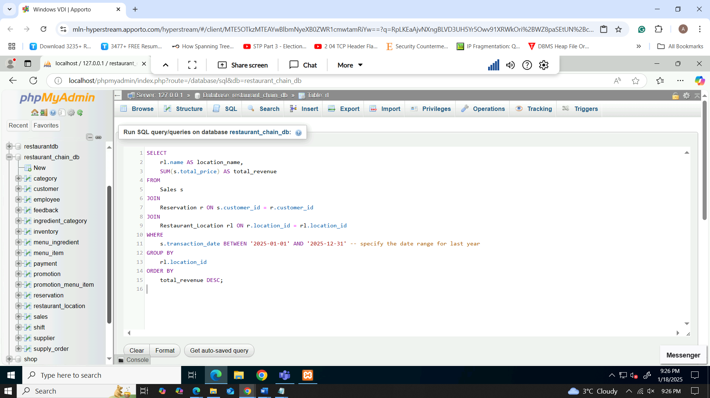

Figure 46: Revenue by restaurant location

This query determines all the ways in which total sales for every restaurant location has been in the year, from 1st January 2024 to the 31st December, 2024. Join that Sales with the Reservation by using the on.customer_id this would help link the sales to specific customers and their bookings. However, it links with the Reservation table and the Restaurant_Location table by location_id to connect restaurants’ locations with each reservation. The SUM function sum a total revenue for all location and the result is grouped by location _id. Last, the results are ranked by the key rating based on the total revenue, showing the most successful locations.

The result of executing the query points out a total sales amount of each location for the restaurant business in the year 2024. It contains name of the location and the total sale in descending order. This assists in determining revenue generating outlets while offering information in terms of financial revenue generated by specific outlets over the past year.

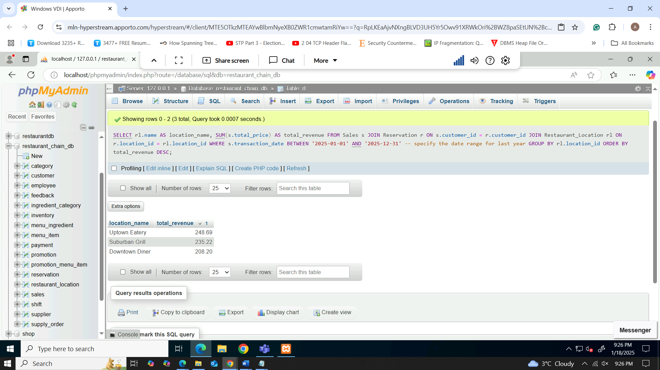

Figure 47: results of Revenue by restaurant location

# Report and Analysis

## Daily Revenue report

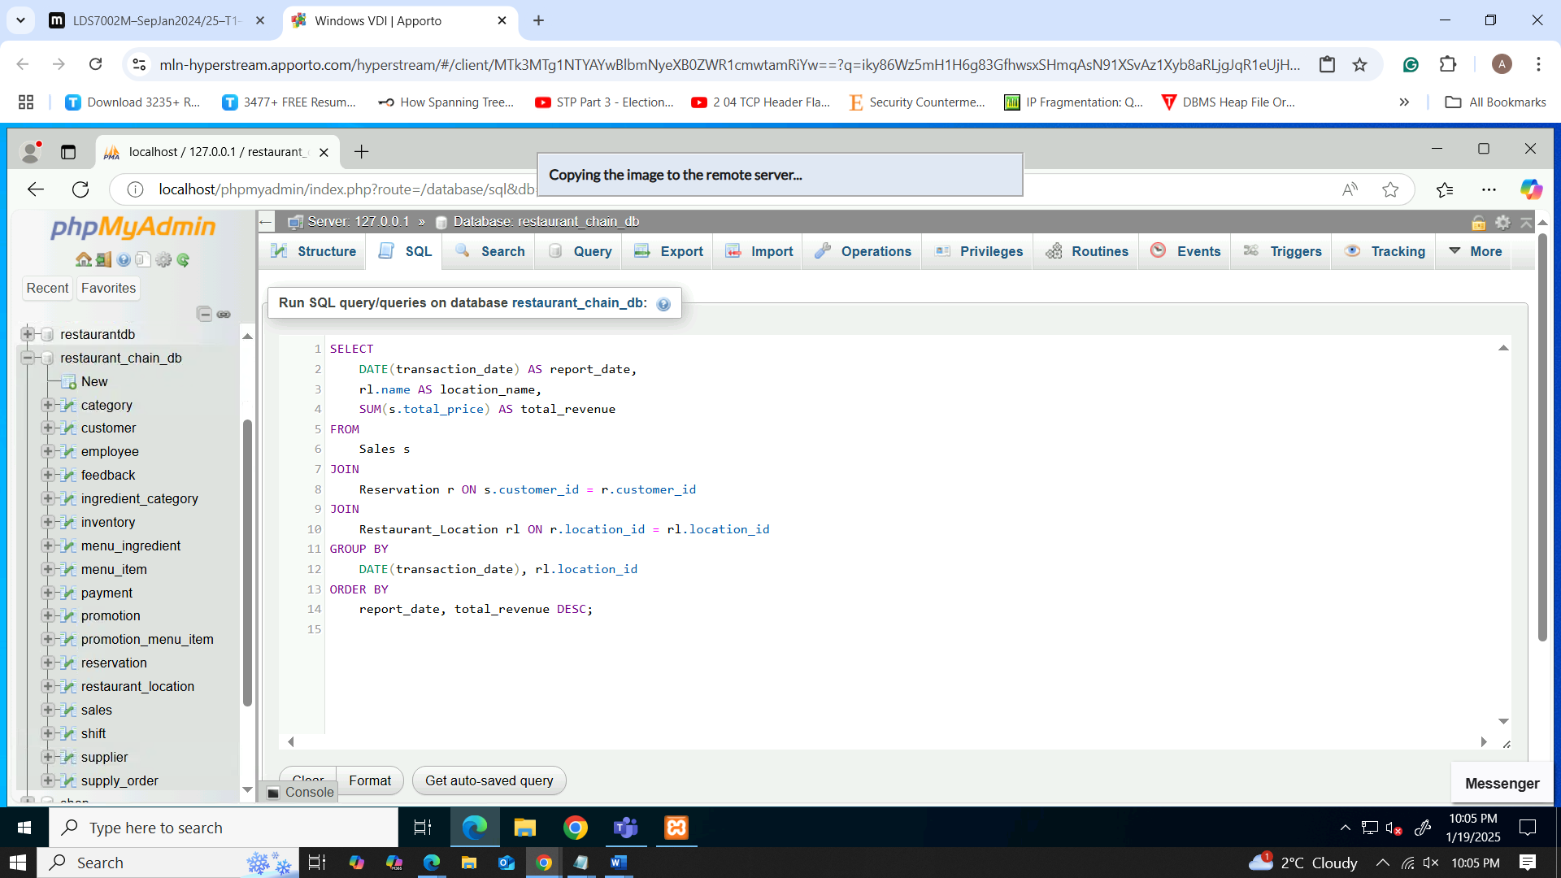

Figure 48: finding daily revenue query

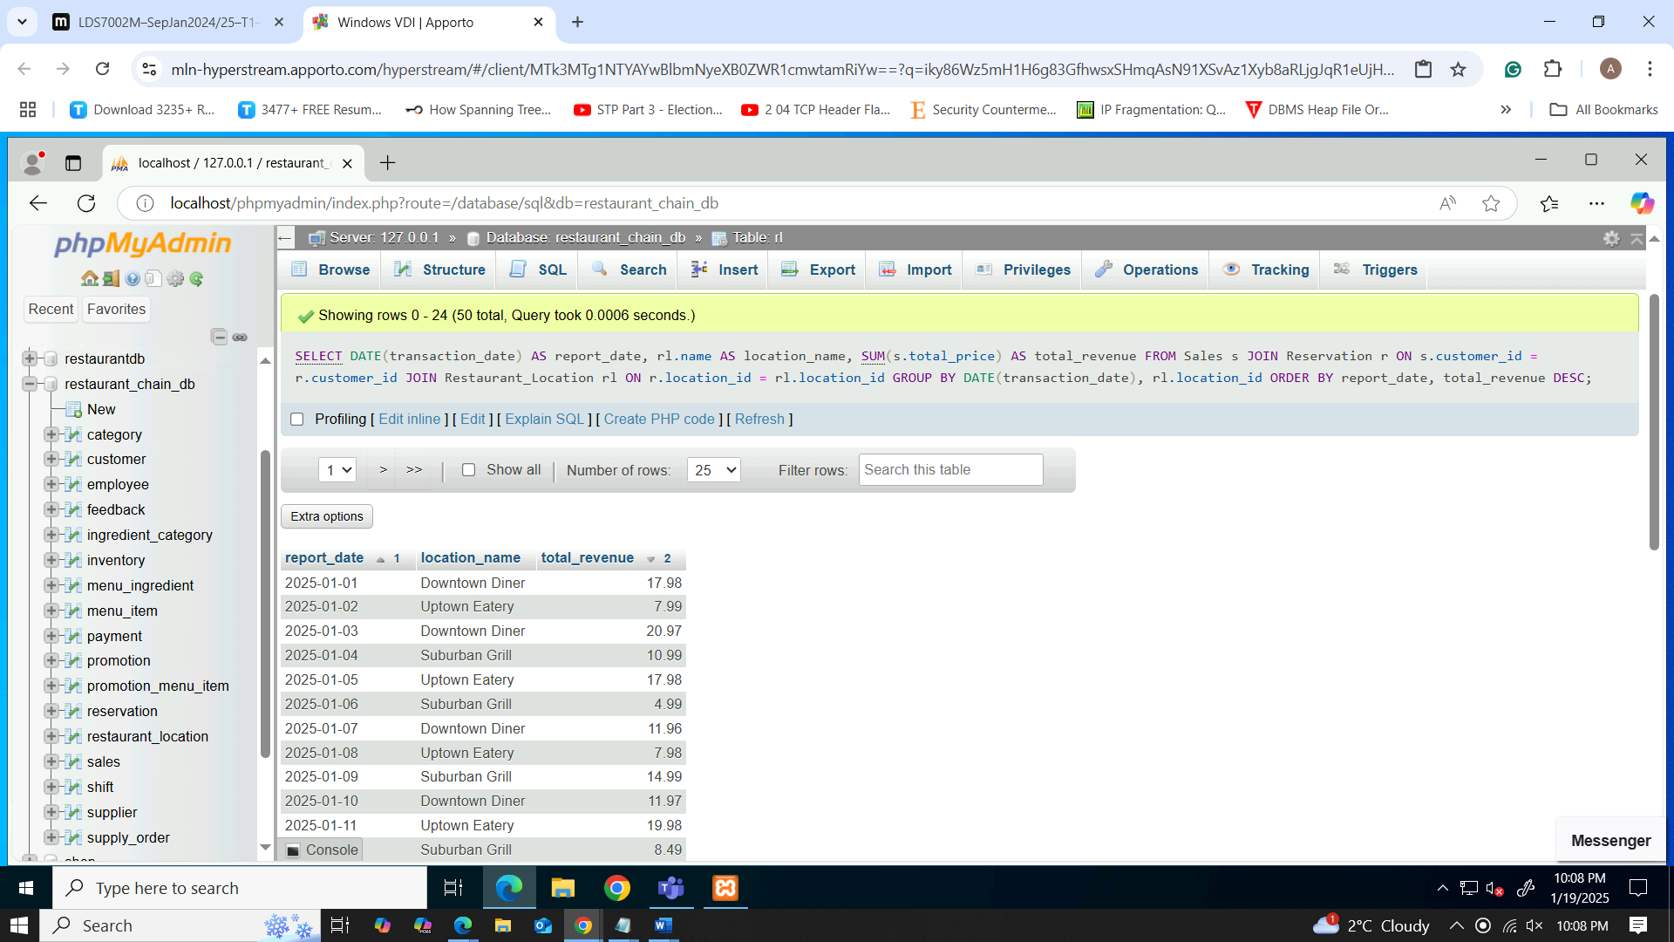

Figure 49: outcome of daily revenue

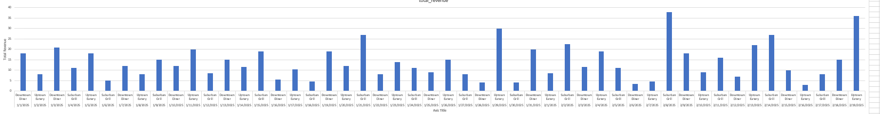

Figure 50: bar char for daily revenue

The data shows daily revenue for three locations: Downtown Diner is a restaurant which implies some creation of it as a real centre of a town/square; Uptown Eatery looks like a creative and, let’s say, progressive eating place in an upper-class area of a town; and finally, Suburban Grill which can be associated with a modern house in a suburban area or just a traditional diner. There are certain months when Revenues at the two restaurants vary, for instance, Suburban Grill, $ 37.98 in the 8/2/2025 and Uptown Eatery $ 35.97 in 19/2/2025. Downtown Diner steady but lower revenues are earned. It can be inferred that Uptown Eatery revenues rise towards the end of January, while the subtlety of Suburban Grill. This mean promotions could extend to Downtown Diner to encourage better performance, while at other areas, peak days could be optimally utilized. Comparing weekdays and weekends can also help to advance recognition of potential for the greatest total sales.

## Itemized Sales by Category

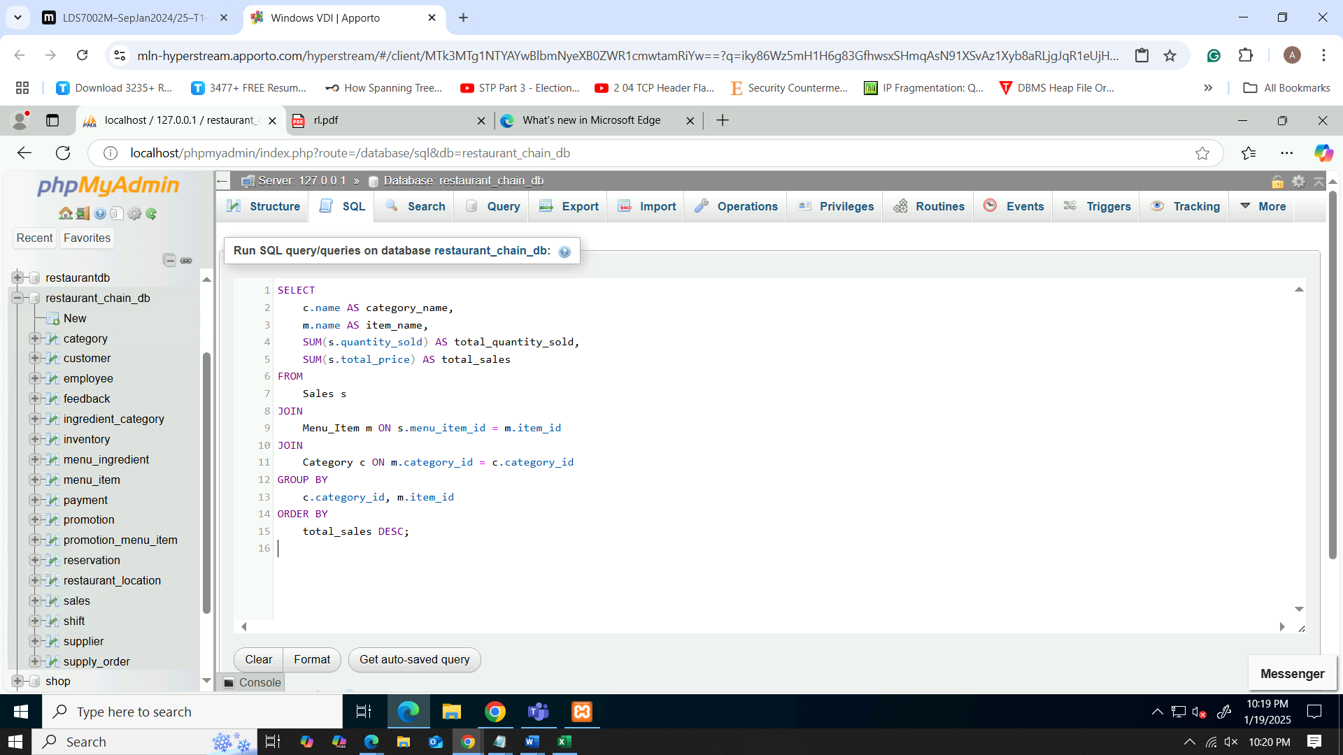

Figure 51: query for itemized sales by category

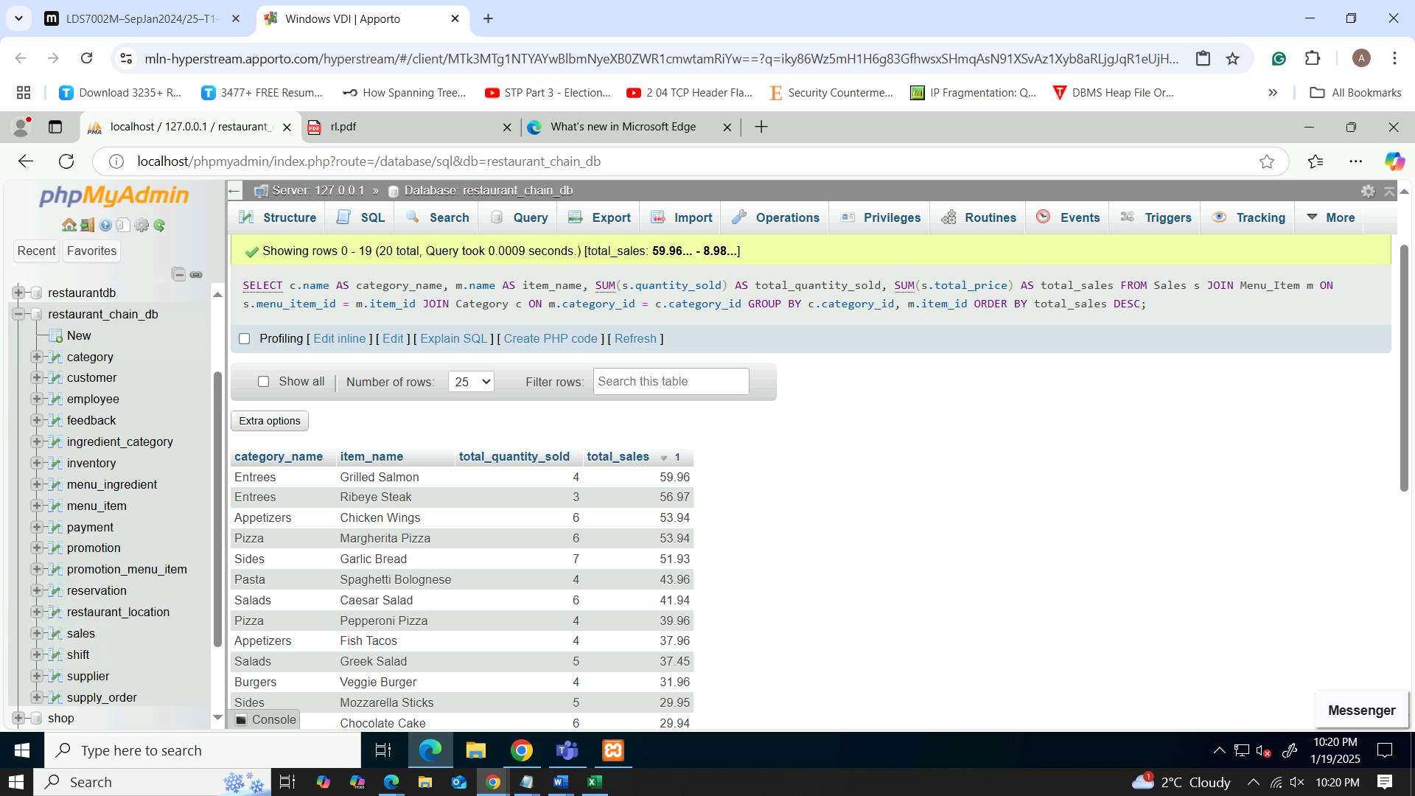

Figure 52: results of the itemized sales by category

Figure 53: pie chart for the itemized sales by category

Using an intersection of sales summary by category in a pie chart displays the total contribution of each category to overall sales and show customers’ favorite food items and those that are most popular. This perspective is relevant to striking the best balance of inventories in a restaurant and changing the menu with some items prioritized. Therefore, if appetizers or beverages tend to sell either higher than entrees, there could be promotions or new additions in that category boost revenues. As with poor quality, variable cost drivers may be altered: some products might be redesigned or rejected to increase gross margin. The calculation of the performance of the distinct categories enables restaurants to detect whether inventory requirements match consumption levels to offer customers preferred products, implement seasonal or promotional menus, and optimize total sales and cost.

## Inventory report

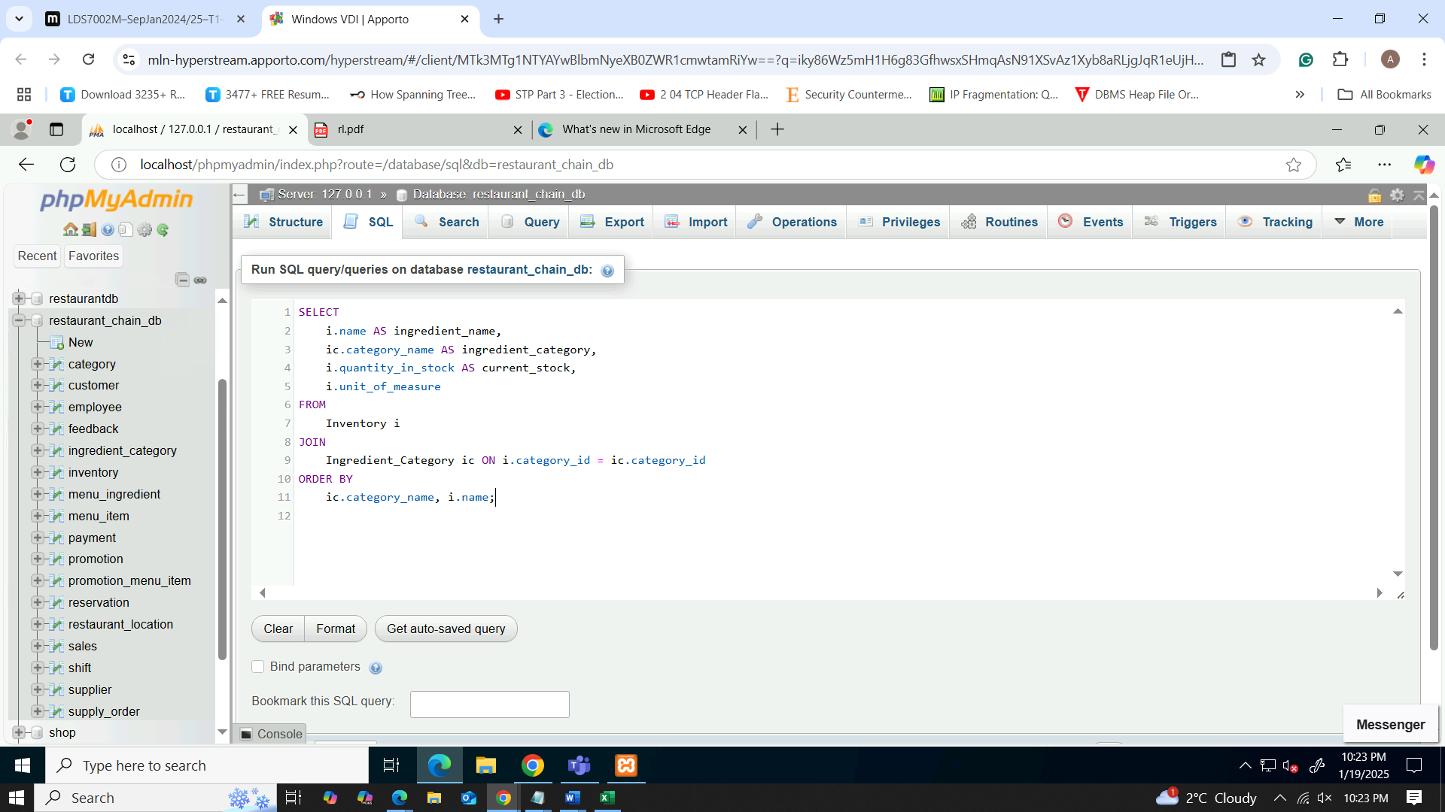

Figure 54: query for inventory report

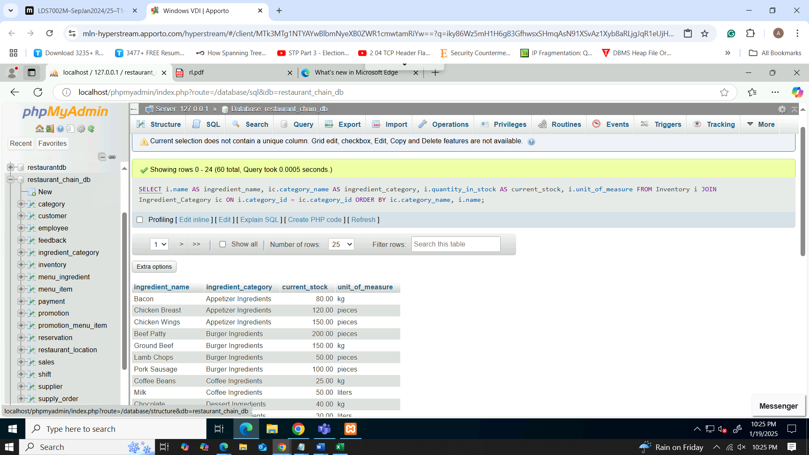

Figure 55: output of the itemized sales

Figure 56: line graph for inventory report

The inventory data provides current stock data for Appetizers, Burgers, Desserts, Drinks, and Salads, in terms of Current Stock. Products such as Chicken wings (150) and beef patty (200) show ample stock, on the other hand, sesame oil (10 litres) and worcestershire sauce (10 litres) may be stocked up loosely. This is because the degree of consumption is high in such categories as Burger & Salad Ingredients; hence require vigilance in order not to stock out. Stock levels can be presented in the form of a bar chart in order to easily pinpoint which items are critical. Subsequent tracking overtime can improve the purchasing decision since purchases will be made basing on the stock available rather than making assumptions and end up with a surplus. The major idea of this strategy is that it helps to organize restaurants’ work, controlling the constantly used products and giving proper attention to the products that are low in stock.

# System Deployment

Database Deployment is a process of moving a database from one environment to another, though it often resides in the Development and Production environments, the process entails checking on data integrity, access settings and easy upgrades (Anon., 2025). Some of the important planning steps are choosing an appropriate DBMS (MySQL, PostgreSQL), deciding the schema that is efficient and designing a logical schema, migration of data and implementing good backup/recovery program. Only a few software tools, including Git for version control and Liquibase and Flyway tools for databases, can track changes in the schema and manage migrations well. How a migration script works, rollbacks, and how to test database changes for stability are some of the techniques important in database changes.

Database Deployment requires Automation to help in terms of the security and maintenance of the databases. This proves that application of scripts, tools and CI/CD pipelines helps to set and maintain particular standards and reduces the levels of errors. Some of the other precautionary measures involve accessing an area’s security, protecting data by encoding, and use of secured connections. Monitoring, and maintenance strategies like performance control, queries manipulation, and timely backup guarantees dependability and growth within a network. The methodologies outlined in this article allow for effective and secure deployments and normal functioning of applications.

So, in this process we can do several ways to deploy the database. First one we can simply configure and apply the permission and share to external. On the other hand, we can use AWS (Amazon Web Service). Its gives high availability, better storage facility and reliability. But it going to charge us for those services.

* Simple share deployment

If one wants to give the external users the ability to use a .sql file for MySQL, then make sure that the file contains legal MySQL SQL statements, and any sensitive information has been removed. It’s perfect to share securely using cloud storage, SFTP, or email, with easy-to-follow download instructions. If necessary, interactions take place within the database, the MySQL server must be set up for external access by adding and saving the parameter bind-address = 0.0.0.0 in the my.cnf or my.ini file, and the firewall must be configured to allow external connections through port number 3306, the user must then create the users needed for the relevant database and providing the relevant permissions. Optionally, while configuring the instance, limit access by IP addresses, to improve security. Preferably, explain to users that they must import the file by using MySQL command-line tools or MySQL Workbench or any phpMyAdmin tool. Addition to that, the process should be secured by utilizing encrypted connections together with safe procedures of sharing such credentials with the users involved and eventually the signification of access evaluations on a regular basis to ensure maximum security of the users’ accounts.

* Cloud (AWS) deployment

to give the external users the ability to use a .sql file for MySQL, then make sure that the file contains legal MySQL SQL statements, and any sensitive information has been removed. It’s perfect to share securely using cloud storage, SFTP, or email, with easy-to-follow download instructions. If necessary, interactions take place within the database, the MySQL server must be set up for external access by adding and saving the parameter bind-address = 0.0.0.0 in the my.cnf or my.ini file, and the firewall must be configured to allow external connections through port number 3306, the user must then create the users needed for the relevant database and providing the relevant permissions. Optionally, while configuring the instance, limit access by IP addresses, to improve security. Preferably, explain to users that they must import the file by using MySQL command-line tools or MySQL Workbench or any phpMyAdmin tool. Addition to that, the process should be secured by utilizing encrypted connections together with safe procedures of sharing such credentials with the users involved and eventually the signification of access evaluations on a regular basis to ensure maximum security of the users accounts.

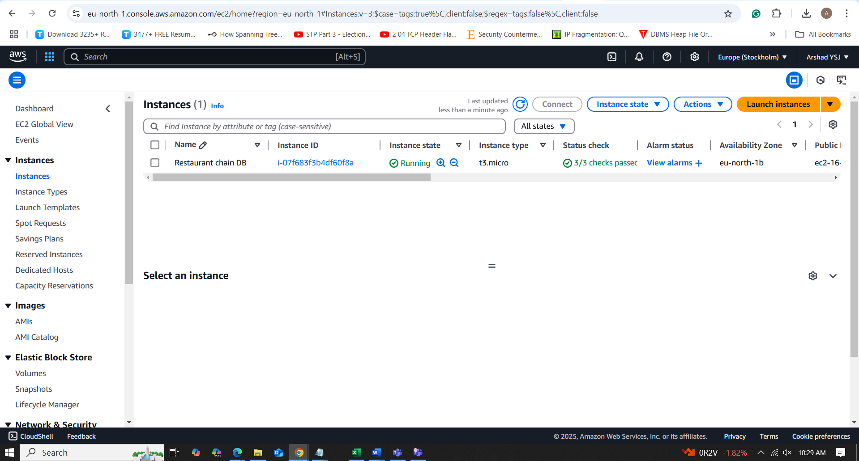

Figure 57: AWS management console for deployment

# Security Consideration

* Management of sensitive data

Pricing, customer names, addresses and other such sensitive data is processed in the strictest confidence to ensure that customer data privacy and data protection laws are considered.

* Secure Storage:

Customer details thus are stored to a database which is encrypted when at rest — meaning when stored and when in transit, typically moving to another network domain. This keeps off would-be intruders since they will not be able to sneak in owing to the tight security features embedded in the use of the technology. Details of the payments that are made to any of the payment gateays are processed and passed in compliance with Payment Card Industry Data Security Standard (PCI-DSS) the payment gateway is PCI compliant, meaning that your credit card details are safe with us. Because this information is not recorded on the internal database of the restaurant, then strictly speaking there can never be data breaching.

* Tokenization:

Credit card details themselves are stored as any other normal text and not as credit card details themselves, rather they are there as a specific reference number, or what is referred to as token. It also makes tokenization whereby even if event data is captured, payment detail cannot be obtained or even created from scratch. It greatly reduces the possibility of fraudulent practices that can be charged on the detriment of the customers’ personal finance information.

By doing so, the system maintains a reasonable level of security and prevents a lack of exposure to hackers.

* Data Protection Measures

As we have seen in restaurant management system, there is need to protect details of customers, transactions, and business operations.

* Encryption Methods:

Basic customer information and Payment details along with Contact details, Orders etc are secured by industry standard AES-256 encryption for data, and TLS 1.2 or higher for transmission. This enables to guarantee the data confidentiality with even if it is intercepted, it cannot be understandable to other people and interfere with the data.

* User Roles and Access Control Mechanisms:

It uses sharp user type (admin, cashier, waiter, kitchen staff) to allow the staff to have access to only that part of the data they need. Permissions limited access only to employees who are permitted to view the financial records of a company, customers’ records or other secret information. For instance, the working staff of the kitchen area can access orders and working staff of the lavishing main kitchen use log-in credentials to open and view customers’ order details and the main managerial staff has access to the different financial and inventory reports.

* Security Standards Compliance

It is imperative that the relevant security standards are adhered to in order to enforce security into the system in addition to legal requirement.

* GDPR Compliance:

The system makes it possible to capture, process, and manage all of the customer data contained in the platform in compliance with the GDPR regulation. Customers also have the right of access to their persona data and/or right of rectification and right to erasure. The features are incorporated to facilitate choice, data retention periods’ monitoring, and to provide the clients with the full transparency of our company’s data processing.

* PCI DSS Compliance:

During credit card transactions within the system, the compliance of the payment card industry data security standard (PCI DSS) is observed. This encompassing involves protecting card holder data, keeping to secure standards while using systems, as well as how to control access. Transactions that are conducted through the website are done using secure payment gateways which are PCI DSS certified.

* Documentation of Design and Technical Parameters

Documentation of such a system is critical in meaning that there should be detailed documentation for future enhancement and expansion of this restaurant management systems. Project, architecture and database documentation outlines the general system design of the solution, structure and definition of the roles to be used and methods of allowing or restricting user access to the different functionalities of the application. In this case, it preserves structures for future modifications, and it informs developers and system administrators of how different features interrelate to exhibit the organization of an existing system as well as the flow of data from one component to another.

Technical focuses on explaining encryption types implemented inside the system, APIs, security measures, installation process, exceptions handling and problem shooting procedures. Its element aliases such features as AES-256 data encryption and a way of transferring data through TLS 1.2 to keep data safe. It also describes API interactions with third-party services as well as payment gateways and their endpoints and ways of authentication (OAuth 2.0). RBAC and MFA polices of granting user access are described to ensure that the user is securely granted access to the system. Further, the deployment process and solutions to various problems are given to keep the system steady and handle regular problems efficiently.

They are equally important in helping the staff to securely and proficiently run the system. These manuals inform staff on how to login, perform payment operations, input customer information and handle frequently encountered problems. They make sure that staff is able to work with minimal hindrances to the security protocols in place. Documentation should be properly done to Favor the system operations in case of new developments, ease expansion and protect data and thereby improving business performance as well as preventing system premature failure.

These security considerations and deployment strategies also means the restaurant management system runs securely, customer data is protected and meets regulations that apply to the industry. This makes customers trust the system, data keep secure from hackers, and business goes on as planned. One advantage of the system is that the deployment could be done securely, which leads to little disruption time; the system also adheres to the set security regulations which lowers legal and financial risks.

# Limitation and future enhancement

## Recognized restriction

* Fragmented connectivity with external platform

The system does not integrate with other systems that are common in businesses today; these include the payment processors, online booking systems and inventory tracking systems. However, this limitation brings into picture manual data entry for external transactions with more chances of errors and time wastage. For instance, the restaurant reservation apps such as the OpenTable or Resy, do not allow for synchronization; forcing organizations to lose opportunities for integration. Likewise, keeping track of inventory in different systems leads to all sorts of problems in managing the stock. Ultimately, the absence of integration raises the work of handlers and promotes the chances of having the wrong data, which results in poor efficiency and effectiveness to accomplish the organizational operations.

* Inability to synchronize menu in real-time approach

This means that the system cannot update menus in real time, but uses manual or update when there are changes to the item and prices. Thus, they limit quick responses to stock status, for example, immediately labeling products as ‘out of stock,’ adjusting prices and new product offerings on menus. Consequently, customers can see obsolete menus on the Internet and become confused and dissatisfied when they cannot obtain the products which are mentioned in the lists. That is, it can create gaps in sales opportunities, compromise the overall consumer experience, and also negatively impact the management of menus in differing formats or outlets.

* Inability to optimize pricing flexibility

The system has no options for dynamic pricing, and the main prices are fixed, and their updates are rare. This linearity also makes it impossible to make changes based on demand like a special rate during peak hours, or a special offer for specific hours in the day or month. Besides, flexibility in raising and lowering prices due to lack of access to lower prices during low demand hours limits the possibility of attracting more clients. Thus, the business fails to optimize the generation of revenue and overlooks several aspects related to the administration of customer traffic and overall responsiveness to the economic environment which all in one way affects the levels of profitability and organisational effectiveness.

* Ensuring privacy and protection of the user

The system complies with basic security standards, but these solutions do not allow the comprehensive protection of customers’ personal information and their data. Currently, it lacks additional protocols on the security of information such as end-to-end encryption. Further, they lack standards set by some of the recent regulations such as GDPR and CCPA that has been implemented. Such weaknesses make data potentially unsafe; this implies that legal ramifications, financial penalties as well as deterioration of market trust pose severe threats to the organization’s reliability and reputation.

* Static reservation capabilities

The reservation model has limited functionality, it only captures simple details such as date, time and number of guests. Specific customer’s requests, which include special desires about food or seating, for example, cannot be provided, which hampers the realization of customers’ needs. Also, the existing system does not intersect with the loyalty programs, or provide the information about the repeated customer preferences within a period; therefore, the provision of a personalized service is limited. In turn, there is a lack of personalization of customer relationships, which can result in a reduced level of satisfaction, and customer turnover rate, increased customer attrition, and loss of the potential for continued business relationships.

* Insufficient Data analytical insights

Yet it has basic reporting and no detailed analytical tools, which affect generating meaningful information across sales, customers, performance and operational measures. It doesn’t give information on the time when you’re most active, which products sell most, your loyal customers, repeat visits, or even the success of your offers and turns in the stock. If these capabilities are absent, the task is delegated to managers who either extract the information manually or turn to external tools to analyze a given topic. It not only leads to the increased time and effort needed for decision making but also to the decrease of overall organisational response capability to business demands.

* Complex stock management

Firstly, the generic functions of the system are quite adequate for basic inventory control; however, they seem insufficient for companies that require more elaborate systems to handle inventory controls. The external environment poses a requirement on its logistical systems that it struggles to manage inventories across various outlets, such as chains or franchises and control perishable inventory with variable shelf life and expiry dates. However, it falls short when it comes to handling of large quantities or raw materials and the arrangement of the supplies from a various suppliers. As a result, these limitations may cause stock out, over stocking or wastage especially in situations where there is more than simple qualifications of inventory management and what is needed is to avoid stock out or wastage.

* Complexity in offering promotion scale

The system experience scalability problems with promotions because of the existence of a many-to-many relationship between promotions and the items on the menu. It becomes nearly impossible to manage them with the growing number of menu items and promotions, let alone add a complicated promotion such as ‘FreeMeal’ – Buy 1 Get 1 Free on specific days. This can cause a problem of performance and make it hard for the staff to implement and monitor the promotions properly hence may lead to confusion, mistake and may even complicate the use of promotions among the employees.

## Improvements

* Interaction with Other Systems

Recommendation: All third party systems should be compatible with the core system and new APIs/middleware should include payment gateways, restaurant reservation services like Open Table and improved inventory control mechanisms. This would cut costs of keying, eliminate errors and make the work more efficient.

* Real-Time Menu Updates

Recommendation: This is the most effective method where the available menu is updated and changed in this system in response to the real time events. With integration to the inventory, this means that menus can be changed automatically according to the stocks that are available.

* Advanced Inventory Management

Recommendation: Adding features like multi-location tracking, expiration management of ingredients and bulk ordering to the list for the improvement of inventory management. This would assist in the complication with inventories requirements and enhance the purchase transactions.

* Promotion and Discount and its management

Recommendation: Implement a new promotion management capability that is capable to effectively manage multiple concurrent and interacting promotions as well as different types of dynamic discount and seasonal promotions. Automate use of the most suitable promotion based on the sale context through a rule-based engine.

* Advanced Data analytical insights.

Recommendation: Integrate a reporting and analytical tool which would be able to point to the sale trends, customer profiles, stock positions or promotion successes. This would enable efficient controlling of management activities by enabling data-driven decision making.

* Supply Chain Management Automation

Suggestion: Automated tools for supply chain management to forecast inventory requirements, generate orders and track deliveries. It would assist in minimising manual errors, building a strong supplier relationship, and maintaining inventory levels.

* Integrating Sales Across Multiple Channels

Suggestion: Integrate a sales system with various sales channels (in-house, online, delivery platforms, etc.) that give you a consolidated view of a transaction. That would help simplify the operations and e sale tracking on each platform accurately.

* Improved Data Privacy and Security

Recommendation: Enhance data protection efforts by utilizing advanced methods of encryption for sensitive user information. The system should be designed to comply with any relevant data privacy regulations (e.g., GDPR, CCPA) and can be achieved by implementing features such as data anonymization, consent management, and periodic audits.

* Enhanced Reservation System

Hold all systems for reservation systems so that they include elements of special request tracking; this can also allow integration for loyalty programs and information with their reservation if they are a regular. This would optimize the customer experience and simplify reservation management.

* Implementation of Dynamic Pricing

Recommendation: Experiment with their menu items, using dynamic pricing based on demand, time of day, and seasonality. This can assist with revenue optimization, especially on peak times or holidays. Machine learning algorithms may be used to anticipate demand and to change prices accordingly.

* Mobile Integration and Online Ordering

Suggestion: Mobile app for ordering or integrating with other existing ordering platform apps It will let customers order, book, and see promotions directly from their phones, which will ensure more convenience for customers and thereby, increase the customer base.

* Customer Reviews and Loyalty Programs

The recommendation is that customer feedback can be integrated along with the loyalty program, so that the repeat customers have their efforts supported. Leveraging customer data for personalized promotions, discounts, and rewards was another potential aspect; tracking customer preferences and feedback to fine-tune offerings to improve satisfaction and retention.

So, with these drawbacks resolved and suggestions followed, such a system would be strongly efficient and adaptive. The system can scale perfectly with the growth of the business offering real-time updates, better integration, dynamic pricing, and analytics, to name a few. Doing so will allow us to operate more smoothly, treat our customers better, and handle insidious complexity as it grows in the future.

# Conclusion

In conclusion, proposed Database Management System (DBMS) will enhance operations within the restaurant chain in the management of reservations, inventory, and sales reports, and the management of customer details. Being a scalable, secure system compatible with GDPR and PCI DSS it provides data security and contributes to the company’s development. Normalization minimizes redundancy and optimizes the data storage and retrieval efficiency, and the system’s modularity enables future extensions, for example, adding online sales and data analysis functionalities. Normalization principles being applied, combined with modularity and scalability will make data quality and performance more efficient when the business expands. In addition, additional features such as dynamic pricing, real time menu and improved data analysis will enhance the strength of decision making and increase operational options. As it stands now there is a good base established for growth and future adjustments will allow the restaurant chain to remain cutting edge, refine its product, and provide the best customer service, which is essential for long term profitability and continued expansion.

# References

admin, 2018. *How to create a database using phpMyAdmin and XAMPP.* [Online]   
Available at: https://skillforge.com/how-to-create-a-database-using-phpmyadmin-xampp/  
[Accessed 19 1 2025].

Anon., 2025. *Basics of Database Deployment | CodingDrills.* [Online]   
Available at: https://www.codingdrills.com/tutorial/deployment-and-hosting-tutorial/db-basics  
[Accessed 20 1 2025].

Anon., n.d. *Requirements Gathering and Analysis in DBMS - Comprehensive Guide.* [Online]   
Available at: https://www.unrepo.com/dbms/requirements-gathering-and-analysis-in-dbms-comprehensive-guide  
[Accessed 10 01 2025].

Belcic, I. & Stryker, C., 2024. *What is an Entity Relationship Diagram? | IBM.* [Online]   
Available at: https://www.ibm.com/think/topics/entity-relationship-diagram  
[Accessed 13 01 2025].

Mayo, M., 2025. *Database Design Fundamentals.* [Online]   
Available at: https://www.statology.org/database-design-fundamentals/  
[Accessed 11 01 2025].

SINGH, C., 2015. *Normalization in DBMS: 1NF, 2NF, 3NF and BCNF in Database.* [Online]   
Available at: https://beginnersbook.com/2015/05/normalization-in-dbms/  
[Accessed 16 1 2025].

# Appendices

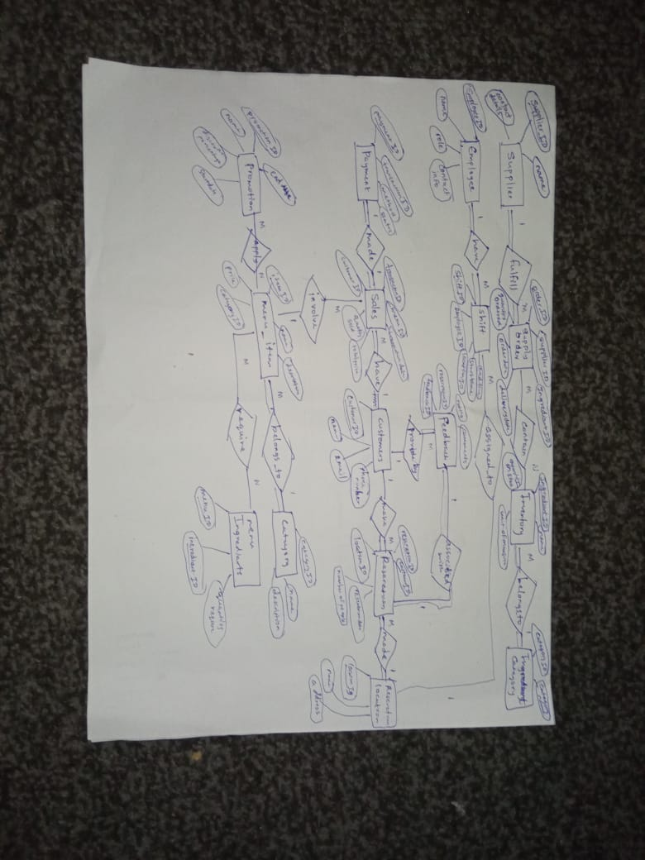

Figure 58: final scatch of ER diagram

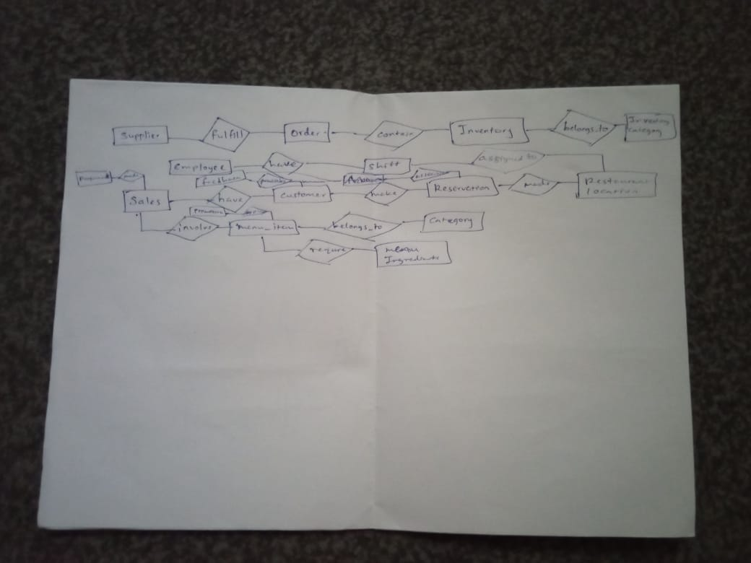

Figure 59: first try of ER diagram scatch